Contents
Contents
Write-Up 1
- Section 1 - Literature Review
- Section 2 - Survey Outline
- Section 3 - Research Question Iterations
Write-Up 2
- Section 1 - Type of Sample
- Section 2 - Approach to get Responses
- Section 3 - Messaging
Write-Up 3
- Section 1 - Survey Design Choices
- Section 2 - Testing
- Section 3 - Invitations
- Section 4 - Implementation Method
Write-Up 4
- Section 1 - Respondents
- Section 2 - Visualizations
Write-Up 5
- Section 1 - Data Analysis
- Section 2 - Descriptive Statistics
- Section 3 - Inferential Statistics

Appendix
- Appendix A - Works Cited
- Appendix B - Survey Maps
  - Week 8 Survey Map
  - Week 9 Survey Map
  - Week 10 Survey Map
- Appendix C - Survey Structure
- Appendix D - Data Dictionary
- Appendix E - Pilot Testing
- Appendix F - Launch and Monitoring Plan
- Appendix G - Data Analysis

Write Up 1
Recruiting and the Use of Artificial Intelligence - Write Up 1
Daniel Laverty, Jessaca Benson, Kaeden Stander, Mazzy Blase, Seoyoung Lee

Contents
Section 1 - Literature Review
Section 2 - Survey Outline
Section 3 - Research Question Iterations

Introduction to Write-Up 1
Artificial Intelligence (AI) has become a cornerstone of recruitment and talent acquisition for many companies. With perceived benefits including efficiency, automation, data-driven decision-making, cost, availability, personalization, reduced human bias and error, and improved candidate quality, many companies have either fully committed to implementing AI in their recruiting practices or are seriously considering doing so in the near future to stay competitive (​​Horodyski 2023). AI is fundamentally changing the relationship between humans and technology, as well as the landscape of job applications, resumes, and the overall recruitment process. While not meant to replace human interaction in the recruitment process, AI serves as an informative guide for recruiters to find and assess highly qualified candidates.
AI recruiting is the process by which artificial intelligence automates tasks related to the screening and selection of potential candidates that would otherwise be delegated to a hiring manager, human resources representative, or other high-level individual in an organization. The appeal is that automating tedious tasks frees recruitment teams to focus more on their overall goals. Furthermore, AI can enable a proactive recruitment strategy, pulling in high-potential candidates and predicting a candidate's level of job satisfaction or success in a role before the candidate even applies. As AI innovation continues, further AI augmentation promises to deliver even more efficient, streamlined processes for both candidates and recruiters. We aim to collect primary data for our project using Qualtrics, a survey platform that offers customization for look and feel and practicality, all with our respondents in mind. With the construction of our survey on AI recruiting, we aim to answer our research question: “How do organizations’ experiences with AI in recruiting (current use, considering use, or not using) differ in their perceptions of candidate acquisition, candidate quality, and AI bias?” We hope to generate descriptive and inferential statistics utilizing concepts such as ANOVA, mean, standard deviation, and bar charts to understand how businesses operate with AI agents for recruitment, and pinpoint areas of contention within the AI recruitment process, highlighting advantages and disadvantages to using AI agents as opposed to traditional recruitment methods.
In this write-up, we will review the existing literature on AI-assisted recruitment and outline initial research questions that informed our early survey development, with all sources being referenced from Appendix A of our document.

Section 1 - Literature Review
Literature Review
While existing literature explores perceptions of AI throughout the recruiting process, there remains a clear gap in research concerning how recruiters, job seekers, and other stakeholders perceive the use of AI compared to traditional recruiting methods. Most prior work focuses on applicant experiences or theoretical ethical debates rather than the practical decision-making and adoption patterns of those implementing or purchasing AI tools. Our study addresses these issues by gathering data on which recruitment stages can be made more efficient with AI, identifying where stakeholders feel human oversight remains essential, and exploring how AI recruiting tools are implemented in real-world staffing contexts.
As the use of AI continues to expand, concerns around responsible implementation, bias, and the human impact of automation underpin nearly every discussion of AI decision-making. Scholars such as Soni (2024) and Hunkenschroer & Kriebitz (2022) highlight the ethical challenges tied to bias replication, privacy and security, data quality, transparency, and the overreliance on automated systems. These issues are especially pressing in recruitment contexts, where AI must make or assist in decisions that deeply affect individuals’ livelihoods and access to opportunity.
Valdivieso (2024) finds that AI is generally perceived positively in early recruitment stages, such as job postings and resume screening, where automation drives efficiency. However, concerns rise sharply when AI is used for final evaluations or candidate selection, where bias and empathy are most critical. Similarly, Horodyski (2023) notes that applicants appreciate AI’s speed and convenience but remain skeptical of its ability to understand human context and emotional nuance.
Cruz (2024) reframes bias as a human-algorithm collaboration, showing that recruiters themselves shape the equity of AI systems through their interpretations and use. Cruz’s analysis aligns with Soni’s (2024) emphasis on human oversight, diverse data inputs, and continuous auditing as safeguards for equitable outcomes. Hunkenschroer and Kriebitz (2022) extend this discussion through a human rights perspective, arguing that transparency, accountability, and consent must be central to AI hiring systems to avoid violating privacy or reinforcing systemic discrimination. Together, these studies reveal that while AI recruiting tools can boost consistency and scalability, they also introduce ethical and operational tensions that demand balanced, informed adoption.

Primary Research
Source 1 - CCPA Laws (Daniel’s Spreadsheet)
Daniel’s analysis of the California Consumer Privacy Act (CCPA) reinforces the growing intersection between data protection law and AI hiring ethics. The rights to know, delete, opt out, and correct data establish a framework that ensures transparency and control, core principles mirrored in responsible AI. The findings underscore that as AI becomes more embedded in recruitment, organizations must go beyond compliance, embedding these principles into every layer of algorithmic decision-making. Bias, privacy, and consent are no longer optional; they are operational requirements that define brand trust and ethical legitimacy in data-driven recruitment.
Source 2 - Introductory Interviews (Kaeden’s Dataset)
Kaeden’s interviews with recruitment and staffing leaders illustrate the practical reality of AI adoption. Most respondents described AI as transformative for efficiency, scalability, and workflow automation, freeing recruiters from administrative burdens. However, leaders also warned of losing authenticity and human connection when AI replaces interpersonal engagement. The interviews reveal a persistent tension between efficiency and empathy, between technological acceleration and the relational foundations of recruitment. Successful integration depends on usability, cost, trust in data quality, and transparent communication with candidates. AI may be inevitable, but human oversight remains essential to sustain trust and bias in the recruitment process.

Secondary Research
Source 1 - Fairness in AI-Driven Hiring (Cruz, 2024)
Cruz’s research deepens the understanding of fairness by emphasizing that human “process experts” who configure and interpret AI systems play an active role in shaping equitable outcomes. Cruz’s paper also warns that even well-designed algorithms can show bias if recruiters rely on outdated habits or prioritize efficiency over reflection. Fairness, therefore, is not built into code; it is enacted through ongoing human choices and organizational culture.
Source 2 - Applicant Perception of AI (Horodyski, 2023)
Horodyski’s work captures the end-user experience. Applicants report appreciating AI’s convenience and responsiveness, but question its ability to fairly evaluate personality, potential, and cultural fit. Horodyski’s findings highlight that algorithmic efficiency does not necessarily equate to perceived fairness, an essential insight for recruitment and employer automation balance.
Ethics of AI Recruiting (Hunkenschroer & Kriebitz, 2022)
Viewed through a human rights framework, Hunkenschroer & Kriebitz’s work raises issues of discrimination, consent, and data misuse. There is an argument for stronger legal and ethical oversight, ensuring that algorithmic hiring remains consistent with fundamental human values. The paper reminds people that AI’s potential to reduce bias depends entirely on how transparency and accountability are operationalized and regulated.
AI Job Matching and Equity (Soni, 2024)
Soni’s study adds a structural layer, showing that AI enhances operational efficiency through automation and predictive matching. However, it can also replicate inequities when trained on biased or incomplete data. The paper concludes that achieving equity requires diverse datasets, continuous monitoring, and ethical auditing to ensure automation supports inclusion rather than undermines it.
Recruiter and Applicant Perspectives (Valdivieso, 2024)
Valdivieso’s study bridges multiple perspectives, including those of AI experts, recruiters, and applicants, to reveal that trust in AI varies by recruitment stage. Stakeholders value automation in early data-heavy tasks, but prefer human judgment in evaluative or interpersonal decisions. The paper reinforces the importance of hybrid models that blend AI’s consistency with the intuition and empathy of human recruiters.
AI Integration in Staffing (Seoyoung & Mazzy’s Document)
Mazzy and Seoyoung’s analysis shows industry trends and job seeker perceptions, underscoring the dual narrative of AI recruiting: one of efficiency and innovation, and concern for bias and human oversight. Their themes, efficiency, match quality, trust, and candidate experience, echo a broader industry recognition that ethical design and accountability must accompany technological progress.

Taken together, these studies reveal that AI’s role in recruitment is both promising and worrying. It offers measurable improvements in speed, reach, and candidate matching, yet it also raises unresolved questions about equity, transparency, and human authenticity. Existing research focuses primarily on the perceived effects of AI, while our study explores how recruiters and job seekers actually navigate, trust, and implement AI agents in practice. By combining legal frameworks (like the CCPA), practitioner insights, and ethical scholarship, our project aims to bridge the gap between theory and application, advancing a more balanced understanding of how AI can be designed and used responsibly across recruitment processes and ecosystems.

Section 2 - Survey Outline
Survey Outline
To develop our survey, we followed a structured, multi-stage process that moved from theory to application. We began by reviewing existing literature on artificial intelligence in recruitment, which is presented in Section 1 - Literature Review and Appendix A - Works Cited, to identify recurring themes, such as fairness, efficiency, bias, candidate quality, and transparency. These themes appeared across studies by Soni (2024), Valdivieso (2024), and Hunkenschroer & Kriebitz (2022), becoming the conceptual foundation for our primary research.
Next, we conducted semi-structured interviews with professionals in the recruiting and staffing technology space to understand how AI is actually implemented in practice, while also looking at existing policy such as the CCPA laws in California. Using a thematic analysis approach, we coded interview transcripts to uncover patterns in how leaders discussed efficiency gains, human oversight, authenticity, and bias management. The thematic approach helped us transform broad theoretical ideas from the literature and primary research into concrete, experience-based insights. For example, while the literature emphasized fairness as an abstract ethical goal, our interviews revealed that recruiters often defined fairness through transparency, explainability, and control over AI tools, concepts we later operationalized into measurable survey items.
After identifying the key constructs, we translated them into clear, behavioral survey items using Dillman’s guidelines and a 7-point Likert scale to capture varying levels of agreement and perception strength. We also differentiated question sets based on each organization’s current relationship with AI, currently using, considering using, or not using AI, to ensure contextual accuracy and later to allow for testing to come in the form of an ANOVA. Our design allowed us to compare how perceptions of efficiency, candidate quality, and bias shift depending on history with AI agents.

Examples of survey items we deducted to for each section include:
Currently Using AI
e.g., AI agents have expanded the reach of our job postings to more applicants.
Considering Using AI
e.g., AI agents could help us reach a more diverse pool of candidates.
Not Using AI
e.g., AI agents could unintentionally favor certain types of candidates.

Through this development process, the survey evolved from theoretical literature constructs to empirically grounded measures informed by real-world experiences. The result is a tool that captures both the perceived advantages of AI recruiting and the ethical, logistical, and cultural factors influencing its adoption across organizations.
Furthermore, we believe that through the thematic process, our survey captures a balanced understanding of how organizations at different stages of AI adoption perceive their role in recruiting. By combining our insights from the interview responses, lit review, and Dillman chapters, we believe our survey now encompasses conceptual depth and practical clarity around the topic of AI agents and recruiting processes. The early stages of our survey map are shown in Week 8 of Appendix B.

Section 3 - Research Question Iterations
Research Question Iterations
Over the course of the project so far, our research focus has evolved from general recruitment processes to a more targeted exploration of AI’s role in hiring. In Week 1, we examined how producing and distributing job postings influences recruitment outcomes. By Week 3, we refined our question to focus on how clients perceive the effectiveness of an AI-integrated recruiting service compared to traditional methods. Currently, our study has centered on organizational experience, comparing how companies that currently use, are considering using, or do not use AI differ in their perceptions of candidate acquisition, candidate quality, and AI bias.

Research Questions
- Week 1: Does producing and distributing job postings influence recruitment outcomes?
- Week 3: How do XYZ Company's clients perceive the effectiveness of its AI-integrated recruiting service compared to its traditional (non-AI) recruiting service?
- Week 6 to Current: How do organizations’ experiences with AI in recruiting (current use, considering use, or not using) differ in their perceptions of candidate acquisition, candidate quality, and AI bias?

Write Up 2
Recruiting and the Use of Artificial Intelligence - Write Up 2

Daniel Laverty, Jessaca Benson, Kaeden Stander, Mazzy Blase, Seoyoung Lee

Contents
Section 1 - Type of Sample
Section 2 - Approach to get Responses
Section 3 - Messaging

Introduction to Write-Up 2
Artificial intelligence (AI) continues to redefine how organizations attract, evaluate, and hire candidates. As discussed in Write-Up 1, our project began by examining the growing presence of AI in recruitment, highlighting its promise of efficiency, automation, and data-driven decision-making, while also addressing the ethical and practical challenges it presents. We established the foundation for our research question “How do organizations’ experiences with AI in recruiting (current use, considering use, or not using) differ in their perceptions of candidate acquisition, candidate quality, and AI bias,” which explores how AI recruiting technology and AI agents shape perceptions of efficiency, candidate quality among for organizations.
Building upon that groundwork, Write-Up 2 focuses on the sampling plan that will guide our data collection. Our goal is to ensure that our survey captures balanced, meaningful insights from the recruitment process, with companies implementing or evaluating AI recruiting tools and deciding whether to implement them or not.
Furthermore, our team is using a non-probability sampling method. We decided a non-probability approach was best because we are targeting organizations from a specific company owned by Kaeden’s father, meaning we would have had a small sample. By focusing on a smaller sample size, we were afforded the opportunity to focus our target population on companies that have already adopted AI in their recruitment processes, organizations considering implementing it, and those who have chosen not to use AI, all of which would have a history of these decisions within their organization.
At this stage, our team focused on continuing to develop the Survey Map that outlined the core themes and question areas for organizational respondents. Using insights from our thematic analysis, we structured the survey around four primary sections: Use of AI in Recruiting, AI Bias, Candidate Acquisition, and Candidate Quality, each linked to specific, measurable variables. The Week 9 Survey Map served as a built-upon framework from the Week 8 Survey Map for identifying constructs such as efficiency, and candidate reach, while the Week 10 Survey Map expanded these ideas into draft question wording, scales, and data types. This step was less about programming the survey and more about refining concepts, ensuring that every question tied directly to our research goals and could later support valid statistical analysis.
In line with Dillman’s Ch 3 and 9, our outreach messaging emphasizes brevity, clarity, and purpose. Respondents are informed that the survey is anonymous, takes five to eight minutes, and contributes to research on the evolving relationship between humans and AI in recruitment. We believe our refined approach helps establish trust and encourages participation while minimizing respondent fatigue.
Overall, Write-Up 2 builds directly upon the theoretical and conceptual foundation of Write-Up 1, shifting our project from broad literature research toward structured framework survey development. By focusing on organizational perspectives and using the Survey Maps to refine our themes, question wording, and measurable variables, we created a clear framework for collecting valid and reliable data in later stages, ready for documentation in Write-Ups. Write-Up 2 emphasized conceptual alignment, refinement, consistency across question areas, and preparation for future survey deployment, laying further groundwork for our study.

Section 1 - Type of Sample
Type of Sample
Our Sample
The sample for our study will consist of recruiting and staffing organizations representing three distinct levels of AI adoption within their hiring practices:
- Organizations currently using AI in recruiting
- Organizations considering implementing AI in the near future
- Organizations not using AI in any form.
By focusing on organizations at different stages of AI adoption, we can capture a range of experiences that reveal how exposure to AI tools shapes perceptions of efficiency, quality. The literature reviewed in Appendix A suggests that these adoption stages often correspond to differing levels of optimism, caution, or skepticism toward AI use in recruitment (Valdivieso, 2024, and Horodyski, 2023).
Furthermore, we are using a non-probability convenience sample, which allows access to professionals within recruiting/staffing and HR who are directly involved in hiring processes. While this approach does not produce a statistically representative sample of say ~50 to ~100 respondents, it ensures that responses come from respondents with practical, experience-based knowledge and a history of AI agents in recruiting technology.

Sample Plan
As mentioned in the our sample section, our study employs a non-probability convenience sampling plan composed of employees, managers, and C-suite representatives of recruiting/staffing organizations. Respondents will include individuals directly involved in recruitment or candidate evaluation, such as recruiters, talent acquisition specialists, HR managers, and C-suite representatives who oversee all of the listed positions. Our level of coverage ensures that each response provides insight grounded in professional experience with AI agents, recruiting systems, and/or traditional recruiting methods.
We aim to collect at least 30 valid responses, which will provide approximately 95% confidence that any given variable falls within +/- 5 percentage points of the population mean. Although our sample size is small, it aligns with the exploratory nature of our study and the project’s timeline.
The survey design and question structure were informed by our Survey Maps, which outline how each theme, AI use, candidate acquisition, candidate quality, and AI bias, translates into measurable variables. The survey will be distributed through LinkedIn and email invitations, targeting individuals in the recruiting/staffing fields. Each group member will be responsible for sharing the survey link within their professional networks to help diversify responses across different industries and organization sizes.
To improve participation and reduce nonresponse, our outreach strategy will follow Dillman’s approach, with a particular focus on recommendations from Chapters 3 (The Importance of Trust and Social Exchange) and 9 (Minimizing Nonresponse Error). We will build respondent trust by clearly communicating the study’s purpose and ensuring anonymity throughout the data collection process. We will also stress the survey’s short completion time (approximately 5–8 minutes) to reduce perceived burden, a technique Dillman identifies as essential for encouraging engagement. To maintain contact and reduce nonresponse bias, we will send midway reminders and final reminders to non-respondents and continue outreach until the desired response rate is achieved. By following these best practices, we aim to produce a diverse dataset that accurately reflects organizations at different stages of AI adoption.

Potential Sample Problems
Although non-probability convenience sampling allows access to qualified and relevant respondents with good knowledge of our topic, it can introduce several potential biases and limitations. Because our outreach will primarily occur through professional networks and email, selection and coverage bias may occur if the sample disproportionately includes organizations already familiar with or interested in AI. Similarly, non-response bias could emerge if organizations with negative experiences or privacy concerns about AI choose not to participate.
Furthermore, these limitations may reduce external validity, limiting the generalizability of our findings to all organizations or industries. Specific sectors, such as large enterprise organizations, may end up being overrepresented compared to smaller or less digitally integrated organizations. Additionally, our sample may end up overrepresenting respondents with favorable attitudes toward AI, skewing our descriptive and inferential statistics.
We hope to address these concerns by clearly reporting demographic information such as organization type and AI adoption category, to provide context for interpreting results. Any imbalances in representation will be acknowledged in our discussion of findings and amended when we provide our data. Despite these challenges, non-probability convenience sampling remains appropriate for an exploratory study of such a small scale, as it enables us to gather in-depth perspectives from professionals with direct experience in the recruitment space, and by grounding our sampling strategy in the frameworks from Appendix A (Works Cited) and Appendix B (Survey Maps), we ensure that our approach remains connected to the conceptual theory with the framework application of our survey design.

Section 2 - Approach to get Responses
Approach to get Responses
To maintain professionalism, organization, and accessibility throughout our data collection process, our team will utilize Daniel’s Colorado email account specifically for questions, feedback, and logistical communication related to the survey. Utilizing Daniel’s email helps as the respondents in our small sample size have a familiarity with Kaeden, therefore, if they are exposed to Daniel for communication, then that bias of familiarity is less likely to occur. Daniel is therefore responsible for monitoring this account daily, reviewing all incoming and outgoing messages to ensure a consistent tone, clarity, and professionalism in every response. However, it’s important to note that Kaeden and Mazzy will also help clarify questions and adjusting the email tone before Daniel sends. While Dillman does not recommend such a method, we want to reduce bias as much as possible, and not exposing our respondents to someone they have easy access to should be the best way to mitigate such bias.
When communicating with respondents, we will follow Dillman’s guidance from Chapter 9 by ensuring that messages are clear, concise, and purposeful. Our messaging includes prompt follow-ups to clarify questions, confirm interest, and provide assistance when needed. Follow-up emails will also serve as reminders to encourage participation among those who have not yet completed the survey. These reminders will be framed positively, thanking recipients for their time and reinforcing the relevance and value of their input.
For respondents who request a copy of the survey results, we will distribute these via a team members Colorado email while reinforcing confidentiality to our respondents. While our goal is not to break the anonymity of our survey respondents, there is also a compromise for us to share the results via email, but as a team, we have a duty of care and security to keep our respondents' information safe. Our outlined approach aligns with our ethical commitment to protecting respondents’ identities, while building further trust by demonstrating transparency and professionalism.
Overall, our communication strategy is designed to create a reliable, transparent, and respectful exchange between the research team and respondents. By maintaining open communication through a trusted team member's authorized email and consistent follow-up practices, we aim to strengthen respondents’ trust, improve participation, and uphold high ethical standards throughout the data collection process.

Section 3 - Messaging
Messaging
Initial Message:
Dear [employee of x organization],

How do organizations like yours feel about using AI for recruitment? We’re conducting a brief survey to evaluate how organizations use or perceive artificial intelligence (AI) in software recruitment technology.

Your input will help us gain valuable insights into how organizations utilize AI to streamline their software recruitment processes. Once completed, your organization may have access to the survey results if interested.

The survey should take about [X] minutes to complete. Your responses will remain anonymous.

[Insert survey link]

Thank you for your time. We look forward to receiving your submission!

Best regards,
[Recruiting/AI Team Member]

Follow Up 1:
Dear [employee of x organization],
How do organizations like yours feel about using AI for recruitment? We wanted to remind you about our ongoing survey on how organizations use or perceive artificial intelligence (AI) in software recruitment technology.

Your input is incredibly valuable in helping us understand how AI is changing software and recruiting practices across industries. The survey takes approximately [X] minutes to complete, and your responses will be kept anonymous.

If you’ve already completed the survey, thank you - we appreciate your contribution. If not, we’d love to hear from you before results are finalized.

[Insert Survey Link]

Thank you again for your time. We look forward to receiving your submission!

Best regards,
[Recruiting/AI Team Member]

Follow Up 2:
Dear [employee of x organization],

How do organizations like yours feel about using AI for recruitment? This is a final reminder about our brief survey on the use and perception of artificial intelligence (AI) in software recruitment technology. The survey will close on [Insert Closing Date].

If you haven’t yet shared your perspective, this is your last chance to contribute to our research and help us better understand how AI is shaping software and recruiting practices. It takes just [X] minutes to complete, and all responses will remain anonymous.

Please take a few moments to complete the survey here:
[Insert Survey Link]

Thank you for your time. We look forward to receiving your submission!

Best regards,
[Recruiting/AI Team Member]

Write Up 3
Recruiting and the use of Artificial Intelligence - Write Up 3

Daniel Laverty, Jessaca Benson, Kaeden Stander, Mazzy Blase, Seoyoung Lee

Contents
Section 1 - Survey Design Choices
Section 2 - Testing
Section 3 - Invitations
Section 4 - Implementation Method

Introduction to Write-up 3
As artificial intelligence (AI) continues to transform how organizations recruit, screen, and hire talent, it is also reshaping how job seekers experience and perceive the recruitment process. Earlier stages of our research built the conceptual foundation for understanding AI’s role in recruitment. Write-Up 1 explored existing literature and introduced our initial research question, focused on organizational perceptions of AI in recruitment, which we called hiring at the time. Write-Up 2 developed our sampling plan and outreach strategy for organizations at varying stages of AI adoption, really building upon the foundation we had set.
Write-Up 3 marks the next stage in our project, moving from planning to execution. In the Write-Up 3 phase, our team designed, tested, and prepared to launch our Qualtrics survey, guided by Dillman’s chapters 3, 6, and 9.

We began by constructing a clear and balanced survey based on the themes from our previous survey maps:
- Use of AI in Recruiting
- AI Bias
- Candidate Acquisition
- Candidate Quality

We then conducted pilot testing with both professionals and peers to refine definitions, remove redundancy, and improve survey flow. Based on that feedback, we finalized our survey in Qualtrics, developed invitation materials to encourage participation, and created a structured launch and monitoring plan to ensure data quality and anonymity.
Write-Up 3 documents, each of these steps. The Survey Design Choices section explains how Dillman’s principles guided our decisions on question wording, order, and layout. The Testing section describes our pilot process, detailing who participated and how their feedback shaped revisions. The Invitations section outlines how we applied Dillman’s concepts to design outreach messages that build trust and encourage participation. Finally, the Implementation Method section summarizes our launch and monitoring plan, outlining the roles, responsibilities, and ethical procedures used to ensure a successful data collection process.
It’s also important to note that we had refined our research question during the Write-Up 3 phase by including the job seeker branch. We wanted to move beyond organizational analysis to consider how AI agents integrated into recruiting technology affects bias and experience across the entire recruitment ecosystem. We wanted to open up both sides of the conversation, as Chris Carruth likes to say!
Therefore, our revised research question now reads as:
“How does the integration of AI agents in recruiting technology shape bias and candidate acquisition outcomes as experienced by recruiting organizations and job seekers?”

Section 1 - Survey Design Choices
Survey Design Choices
The development and decisions of how we decided to approach our survey was grounded in Dillman’s chapters 3, 6, and 9, which emphasized trust, clarity, and balance between respondent experience and research. Our design drew from the organizational themes outlined in Appendix B (Use of AI in Recruiting, AI Bias, Candidate Acquisition, and Candidate Quality). During the time between Write-Up 2 and Write-Up 3, we expanded our survey to include job seeker experiences related to bias, trust, and transparency in AI-driven recruitment, opening up both sides of the conversation.
Question Types and Format
Our survey primarily used 7-point Likert-scale questions (6 points we would count and a 7th “Don’t Know”) to measure participants’ attitudes and perceptions with precision. Using the 7-point structure allows for statistical comparisons between organizational groups (currently using, considering, or not using AI) and across respondent types (organizations and job seekers). Following Dillman’s chapter 6 recommendations, Likert scales offer a consistent interpretation that the respondent can get familiar to, while reducing cognitive load and excess stress.
Question Wording and Neutrality
All questions were intentionally worded to maintain neutrality and clarity, as leading or assumption-based phrasing was recommended to be avoided based on the Dillman chapters. For example, asking “Our recruiting process relies extensively on AI agents to complete recruiting tasks?” instead of “How has AI improved recruiting for you?” We also defined Terms such as AI agents, recruiting technology, job seekers, and candidate quality within the survey using hover-over JavaScript tooltips, providing accessibility without cluttering the question text.
The JavaScript feature, refined through pilot feedback, ensured that both technical and non-technical respondents could engage confidently, a practice which aligned with Dillman’s chapter 6 guidance on reducing ambiguity.
Order and Visual Flow
Our survey followed a funnel approach - beginning with broad experience-based questions to establish a level of background, while still maintaining anonymity. Gradually, we narrow to specific evaluations of bias and candidate outcomes on the organizational branch, and awareness, bias, confidence, and outcomes on the job seeker branch. Maintaining the branching structure encourages thoughtful responses and reduces early fatigue as each set of questions is specifically narrowed for that respondent type.
Visually, our survey was designed with simplicity in mind: uniform fonts, consistent spacing, and neutral color schemes ensured readability and minimized distractions. Each section header is clearly marked, with transitions between topics and summaries at the start of each section, all of which improves navigation and comprehension. The final survey structure, presented in Appendix C, reflects these design principles and provides a logical, respondent-friendly flow.

Section 2 - Testing
Testing
To ensure our survey had clarity and usability, we conducted pilot testing guided by Dillman’s emphasis on pretesting and iterative feedback in chapter 6. Our approach combined evaluation with user testing to identify areas for improvement before full deployment.
Pilot Participants and Feedback
Each member of the research team contributed to the pilot process, distributing the survey to a range of individuals with relevant perspectives. As detailed in Appendix E:
- Kaeden & Mazzy distributed the survey to Jack, CEO of Staffing Future. His feedback focused on refining definitions and ensuring no duplication across sections. He confirmed the survey’s logical flow and offered advice on improving sample reach.
- Daniel piloted the survey with his supervisor from the Office of Financial Aid at CU Boulder, who noted that some questions in the “Considering AI” section appeared repetitive but praised the overall clarity and flow.
- Seoyoung shared the survey with a corporate professional, who appreciated the inclusion of definitions but suggested making explanatory text more concise.
- Jessaca piloted the survey with her father, a Walmart Distribution hiring manager, who highlighted the need for consistent terminology and the importance of defining terms early for clarity.
Revisions and Improvements
Our pilot feedback led to several refinements:
- Removed overlapping or redundant questions in the “Considering AI” branch.
- Simplified and unified definitions across sections to prevent repetition.
- Condensed explanatory text above definitions for easier readability.
- Reordered question flow to improve logical transitions between topics.
Overall, our pilot testers reported that the survey was intuitive and brief, averaging between five and eight minutes to complete. Their positive feedback confirmed that the survey effectively balanced clarity, relevance, and flow while remaining concise enough to encourage full participation with reduced fatigue.

Section 3 - Invitations
Invitations
The invitation process was guided by Dillman’s chapters 3 and 9, which emphasized increasing perceived benefits, reducing costs, and building trust with respondents.
Message Design
Each invitation we sent out introduced our research team, the survey’s academic purpose, and the assurance of anonymity. We highlighted that the survey would take only around five to eight minutes to complete and explained how respondents’ input could help shape understanding of AI agents in unison with recruiting.
To reflect Dillman’s principles of social exchange, messages framed participation as mutually beneficial:
- Organizations were told their input could inform best practices and bias AI agent implementation.
- Job seekers were told their perspectives could help make hiring systems more transparent and equitable.
The tone remained professional but approachable, ensuring that potential respondents felt respected and valued.
Follow-Up and Communication
We sent one initial invitation, one reminder email midway through the data collection period, and one last reminder email right before we were about to close the survey. The reminders were brief and courteous, expressing appreciation for previous consideration while noting that the survey remained open, and that the respondents' input was still very much valued. All communications were distributed from Daniel’s Colorado email in conjunction with our invitation plan; however, the rest of the team was also copied in on the email, which served as a contact channel for inquiries.
Respondents who requested survey results will have them distributed via a team member's Colorado email after analysis is complete, maintaining confidentiality, as it is impossible to remain anonymous while also promoting transparency. We believe this strategy reflects Dillman’s chapter 9 emphasis on clear, ethical follow-up communication to improve response rates, and is the best way for us to share our survey results with the respondents who wanted information. All of our messaging can be found in Write-Up 2.

Section 4 - Implementation Method
Implementation Method
The implementation and monitoring phase operationalized the survey plan developed in earlier stages. Appendix F details the roles, responsibilities, and procedures that guided data collection. However, it is important to note that the plan has been adjusted to now designate a single member’s Colorado email for fairness and to compensate for the fact that we did not have enough time to create a dedicated inbox.
Survey Launch and Monitoring
Our survey launched at 8:00 AM on November 11, 2025, and remained open for approximately two weeks. It was distributed via LinkedIn, email invitations, and word of mouth, ensuring participation from both organizations and job seekers.
Team members monitored response activity daily using Qualtrics analytics. Mazzy, Daniel, and Kaeden were responsible for reviewing the first 20–30 responses to identify any errors, such as skipped questions, duplicate entries, or repetitive response patterns. All issues were monitored in the Qualtrics analytics tab, with corrections being made, and flags being issued to those respondents' results. Daniel documented any problems and coordinated with Mazzy and Kaeden to resolve them efficiently.
Bounces and Response Management
Seoyoung and Jessaca managed survey bounces by verifying email addresses, and resending corrected links. The process ensured that all intended respondents had the opportunity to complete the survey.
As was our plan, a dedicated project email account was meant to be monitored regularly for respondent inquiries or error reports. However, as we didn’t have enough time to create such inbox, utilizing a team member's Colorado email, in this case Daniel’s email, still provided us with an approach that maintained professionalism, and consistent communication aligning with Dillman’s recommendations for improving respondent engagement through trust and reliability.
Confidentiality and Ethical Practices
All collected data we collected was anonymous, we didn't collect any identifying information (such as email addresses for follow-up) which helped aid the anonymous process. When sending post-survey results, we once again utilized a team member's Colorado email, an approach which ensured ethical compliance, trustworthiness, and respect for respondent privacy, while still maintaining our professionalism, reflecting Dillman’s guidance on fostering transparency.

Write Up 4
Recruiting and the use of Artificial Intelligence - Write Up 4

Daniel Laverty, Jessaca Benson, Kaeden Stander, Mazzy Blase, Seoyoung Lee

Contents
Section 1 - Respondents
Section 2 - Visualizations

Introduction to Write-up 4
Once our survey officially launched and responses began coming in, our focus shifted from design and testing to understanding our respondents. Our project had moved beyond the structure of the survey itself and began to look at the people and organizations who shared their perspectives on our topic of AI recruiting software and AI agents.
Write-Up 4 is set to bridge the gap between our first three Write-Ups and Write-Up 5. Write-Up 1 outlined our literature review and initial research question, Write-Up 2 defined our sampling strategy, and Write-Up 3 detailed our launch, monitoring, and piloting changes.
Our goal in Write-Up 4 is threefold. First, to describe who participated in the survey, both organizations and job seekers, and how their participation represents the dual perspectives central to our study. Second, to summarize demographic and professional characteristics that contextualize the data we collected. And third, to preview the statistical framework that will guide our interpretation of these findings in Write-Up 5.
By outlining who contributed to the survey and what experiences they share, we are able to provide a critical background for understanding how AI recruiting software and AI agents vary across adoption stages between organizations and job seekers. This goes beyond merely describing the characteristics of our participants; it provides a critical foundation for interpreting how each group perceives and utilizes AI technologies, as well as how these differences influence the broader recruitment process.

Section 1 - Respondents
Respondents
Our outreach efforts through Email, LinkedIn, and word of mouth resulted in responses from both organizations and job seekers. Among organizations, participants represented all three AI groups (currently using AI, considering using AI, and not using AI). Having such a range of responses allowed us to align with our original sampling plan and compare perspectives across different levels of experience with AI agents.
Organizational respondents provided valuable insight into how AI is used to improve efficiency, support recruiting decisions, and manage candidate quality. Meanwhile, job seeker responses provided valuable insight into how the same AI systems are experienced through the lens of an applicant. Many agreed with some of the unfair biases around automated screening tools and AI chatbots, while also noting negative experiences with AI agents for resumes regarding bias, transparency, and trust.
Our Demographic
Our respondents represented a small range of professional experience levels, organizational types, and demographic backgrounds. Among organizational respondents, experience mainly centered around executives of startup companies, however, we expected to receive a small pool of data. We gained insight into how large enterprise companies operated with or without AI, enabling us to compare their adoption of AI agents with that of the small startups group.
Job seeker respondents also reflected a diverse range of experiences. Many of our respondents were either recent grads or students still in college. Several respondents noted that their experience with AI agents and recruitment software systems occurred during resume screening, which we could tell due to the heavy amount of agreements. While our survey and sample used a non-probability approach, the variety of perspectives contributed to a richer dataset, allowing us to make these meaningful comparisons between organizations and job seekers.

Section 2 - Visualizations
Visualizations
Figure 1 - Distribution of Respondents by Role
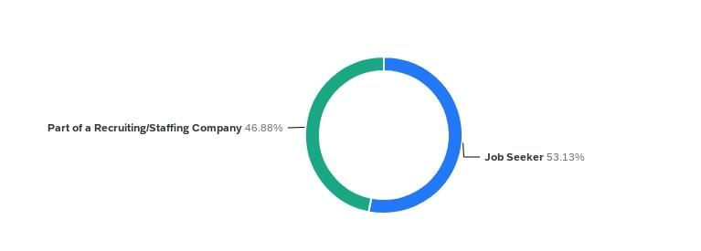

Figure 1 shows that, through the distribution of respondents by role, we can see a nearly even split between job seekers (53.13%) and recruiting/staffing professionals (46.88%). The balance between respondents indicates that our outreach strategy was effective in engaging primary perspectives within the recruitment ecosystem. Job seekers represent the candidate experience, offering insights into how AI agents influence their perception of bias and transparency. On the other hand, organizational respondents shed light on the operational use of AI agents within their organizations. We gain insight into how they are applied to streamline tasks, such as resume screening, sourcing, and interview scheduling. From our baseline, we can then analyse and meaningfully compare perceptions of efficiency and bias between those implementing AI agents and those who are not.
Figure 2 - Type of Position Sought by Job Seekers
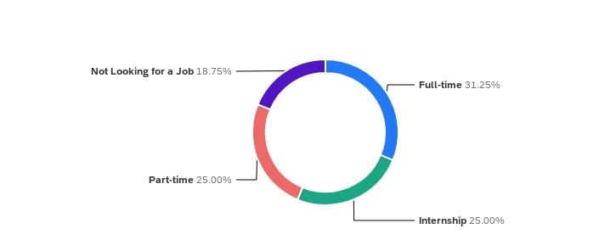
Figure 2 shows that job seekers are distributed across full-time (31.25%), part-time (25%), and internship (25%) positions, with 18.75% of our respondents in the job seeker type not looking for work. Such a variation in respondent type demonstrates that the AI recruitment process is relevant to multiple stages of career development, ranging from early-entry applicants to professionals seeking stable, long-term employment. The presence of individuals not actively seeking jobs also suggests that some level of awareness or indirect experience with AI agents and recruiting systems indicates a broader public familiarity. The variety of employment goals also allows us to explore how AI agents in recruitment may differently affect individuals depending on the job type, as expectations vary between internships, part-time, and full-time positions.

Figure 3 - Duration of Job Search by Employment Type
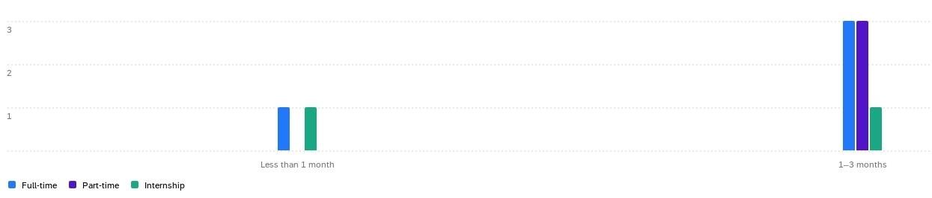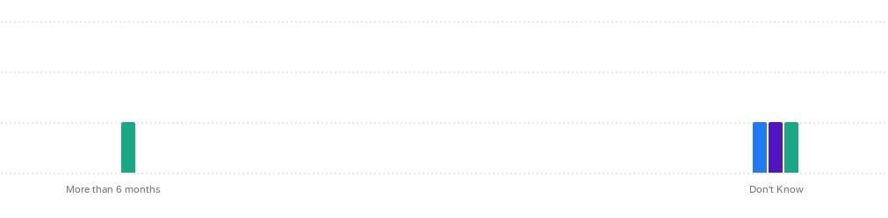
Figure 3 explores how long job seeker respondents have been searching for their relevant employment type. The majority reported actively searching within the last 1-3 months, while smaller groups reported searching for work within the last few weeks and as far out as over the previous 6 months. The data therefore suggests that most respondents are currently navigating the job market at an active stage, rather than reflecting on past experiences. We can also see that internship seekers tend to search a little longer for positions compared to full-time or part-time applicants. These findings reinforce that AI agents and recruiting technology are increasingly shaping real-time applicant experiences, as active job seekers interact with screening tools and automated AI agents during their search.
Figure 4 - Organizational Use of AI-Assisted Recruiting Technology
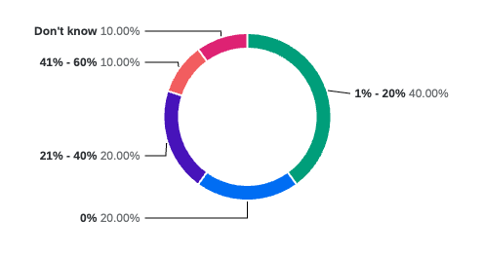
Figure 4 focuses on AI adoption within organizations. 40% of respondents reported using AI for 1-20% of hires, another 40% for 21-60%, while 20% indicated no AI use. The data demonstrates that a significant majority of participating organizations have already begun integrating AI agents into their recruiting processes. The data also suggests that a transitional stage within industry AI agent adoption is here, with organizations now using AI primarily as a sourcing and evaluation tool, confirming the results of what job seekers are seeing. Therefore, these findings align with broader market trends showing partial but accelerating adoption of AI agents in organizational functions. As adoption of AI agents expands, organizational readiness and perceptions of bias will be key to ensuring these systems enhance efficiency without corrupting the ethics of recruiting job seekers.
Statistical Foundations for Write-Up 5
For Write-Up 5, we will analyse our results through both descriptive and inferential statistics. We will utilize descriptive statistics to summarize trends through measures of central tendency (mean, median, and mode) and variability (range and standard deviation). These statistics will provide an overview of how respondents perceive the influence of AI agents in recruiting in areas such as efficiency, bias, and candidate quality.
Inferential tests (such as ANOVA and t-tests) will be used to explore whether perceptions differ significantly between organizations at different levels of adoption stages, between both organizations and job seekers. Additionally, we will determine whether Cronbach’s alpha can be used to assess internal consistency across multiple items, as shown in Appendix D.

Write Up 5
Recruiting and the use of Artificial Intelligence - Write Up 5

Daniel Laverty, Jessaca Benson, Kaeden Stander, Mazzy Blase, Seoyoung Lee

Contents
Section 1 - Data Analysis
Section 2 - Descriptive Statistics
Section 3 - Inferential Statistics

Introduction to Write-up 5
Write-Up 5 caps off our project with the final interpretation and data analysis of our project. Building on the foundation laid in earlier stages of our project, this final phase focuses on analyzing the responses gathered from both organizations and job seekers to better understand how AI agents, in conjunction with recruiting technology, shape perceptions of bias.
In Write-Up 1, we established the theoretical groundwork and identified a potential research question we wanted to look further into. Write-Up 2 outlined our sampling strategy and data collection plan, while Write-Up 3 documented the piloting phase leading up to survey launch. Write-Up 4 then introduced our respondents, including their identities, workplaces, and interactions with AI agents.
Using the data compiled in Appendix G, this write-up presents descriptive and inferential statistical findings drawn directly from our survey results. Our descriptive statistics summarize overall trends and patterns across organizational and job-seeker groups, while our inferential statistics, particularly a t-test for unequal variances, examine whether perceptions of AI bias differ significantly between these groups. Together, these methods provide insight into how trust and skepticism toward AI agents in the recruitment technology space are distributed.
Ultimately, all of our work is tying back into the essential research question we revised in Write-Up 3:
“How does the integration of AI agents in recruiting technology shape bias and candidate acquisition outcomes as experienced by recruiting organizations and job seekers?”

Section 1 - Data Analysis
Data Analysis
Our dataset was exported directly from our Qualtrics survey and cleaned in Microsoft Excel by Kaeden to ensure consistency and accuracy. Missing or incomplete data were excluded from the final analysis, and variables were numerically coded using our 7-point Likert scale (1= Strongly Disagree to 6 = Strongly Agree / 7 = Don’t Know). Respondents were then sorted into groups based on whether they were members of organizations or job seekers.
All data processing, summaries, and statistical tests were conducted in Excel. Means, standard deviations, and the t-test for unequal variances were focused exclusively on bias perception variables and questions, allowing for a direct comparison of organizations' and job seekers' attitudes and perceptions toward bias in AI agents in conjunction with recruitment technology.
Our two-part approach used both descriptive and inferential tests. This allowed for the evaluation of general sentiment and determination of whether observed differences were statistically significant.

Visuals
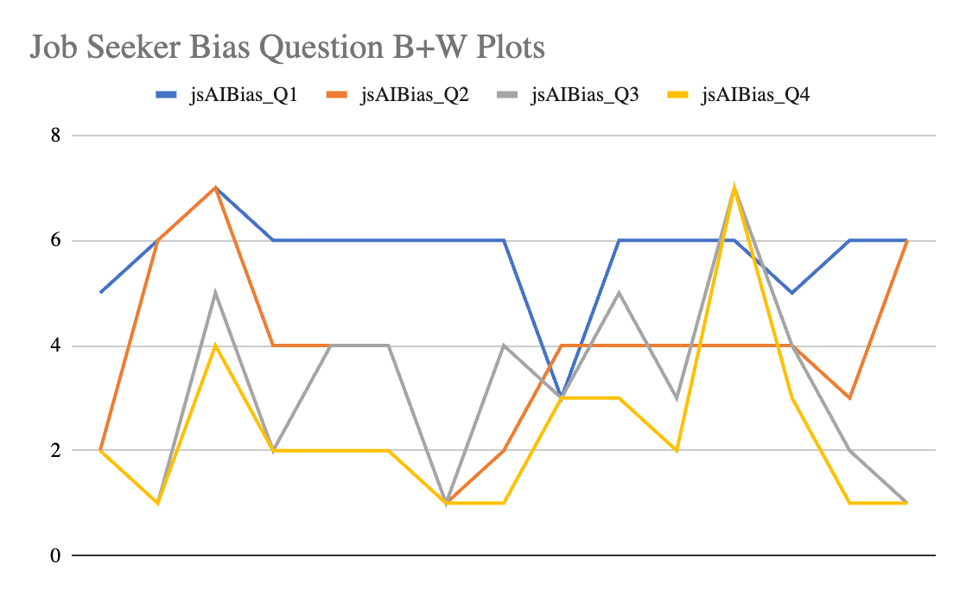
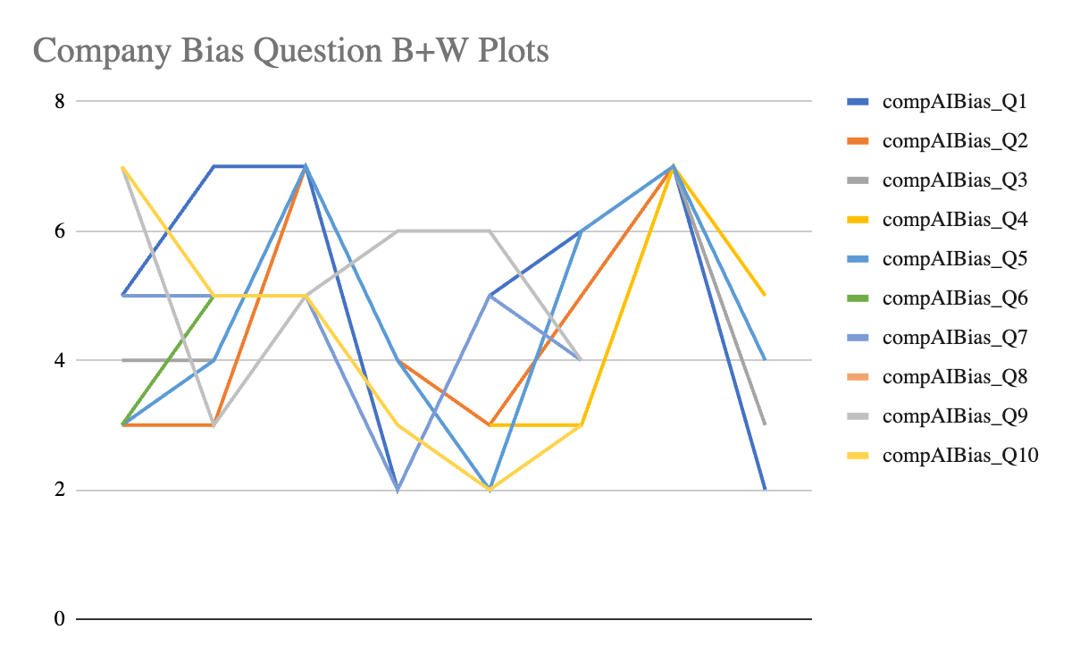

Section 2 - Descriptive Statistics
Descriptive Statistics
Our descriptive analysis results from Sheets 2 and 3 of Appendix G highlight clear contrasts between how organizations and job seekers perceive AI agents' bias.
Company Respondents
Organizations currently using AI expressed less concern about bias for AI agents in conjunction with recruitment systems. The respondents' scores for organizations currently using AI averaged 4-6, reflecting a more positive attitude towards minimizing bias through algorithmic consistency. Questions included evaluating algorithmic recommendations that are unbiased and accurate, and examining how diverse the candidate pool has become with the aid of AI agents.
Organizations still considering AI scored slightly lower, averaging 3-5. The consensus was that there was an openness to adopting AI if clearer safeguards were put in place. However, among organizations that were not currently using AI, scores ranged from 2 to 5, indicating that these organizations were skeptical of adopting AI, even when clear safeguards were implemented. The question content was very similar for both respondents and for those who answered that they are currently using AI.
Job Seeker Respondents
Job seekers responded similarly to those in the company profile, considering using AI. Their scores ranged from 3 to 5, reinforcing the idea that there is greater hesitation toward AI agents. Many respondents viewed AI agents as efficient tools capable of identifying applicants, but at the same time, they expressed concerns about whether AI can evaluate candidates without bias and whether it might disadvantage certain individuals in the decision-making process.
Cross-Group Observations
When combined, the descriptive statistics revealed a consistent pattern: organizations view AI as a functional solution to human bias, while job seekers view it as a source of potential bias. Sheet 5 of Appendix G further details the divide between organizations' and job seekers' perceptions of AI agents' bias, with a clear upward trend being shown in trust among AI agent-using organizations, compared to more moderate responses from job seekers.

Section 3 - Inferential Statistics
Inferential Statistics
Inferential testing, conducted in Sheet 4 of Appendix G, examined whether there was a statistically significant difference between organizations and job seekers regarding perceptions of AI agent bias. The t-test for unequal variances compared mean responses to bias items, determining whether the differences in bias perception were likely due to chance or represented a fundamental divergence in attitudes.

T-Test Results: Bias Perception
The t-test results indicated a statistically significant difference between the two groups (p < 0.05). After completing our Cronbach’s alpha and determining it was acceptable to combine bias question results across the two groups, we found that organizations had a combined mean of 9.3, while job seekers had a combined mean of 7.9. Therefore, across a range of scores, organizations were less concerned about bias from AI agents than job seekers, who seemed more skeptical about AI agent adoption when applying for jobs.

Interpretation
Our results provide meaningful insights into our guiding research question, which asked how the integration of AI agents in recruiting technology shapes bias and candidate acquisition outcomes as experienced by recruiting organizations as well as job seekers. After analysis, we believe that the level of familiarity with AI recruitment tools could shape perception. Respondents who were members of organizations tended to view bias as manageable through system design and human oversight, potentially causing organizations to perceive AI recruitment tools as having less bias and potentially skewing the organizations’ group analysis.
In contrast, job seekers perceive AI recruiting tools with greater caution, with concerns focused more on accountability and transparency. Differing perceptions may be because job-seeking respondents are more likely to lack an understanding of how organizations use AI agents, or simply because job-seeking respondents experience AI from the other side of the recruitment process, in which AI agents play a role in whether or not they are given a job.
The divide in perceptions of AI recruiting tools in organizations vs job seekers mirrors a larger discussion in AI ethics, where the same technologies that promote objectivity and speed can also obscure bias when used without transparency. Furthermore, such contrasting perspectives highlight the importance of evaluating the impact of AI integration in recruiting bias from multiple viewpoints. Opinion and perception of AI recruitment tools will differ based on the entity being asked. For example, job seekers seem to perceive AI recruitment agents as having a more negative impact on bias as compared to employees of recruitment organizations. As AI is being used more and more in the recruitment process, it is important that all parties, such as job seekers and recruiting employees, feel comfortable with how AI agents are used in order to maintain trust and transparency throughout the recruitment process.

Appendix

Appendix A - Works Cited
Appendix A - Works Cited
Cruz, Ignacio Fernandez. How Process Experts Enable and Constrain Fairness in AI-Driven Hiring. International Journal of Communication, 2024.
Horodyski, Piotr. “Applicants' perception of artificial intelligence in the recruitment process.” Science Direct, ESCP Business School, 14 June 2023, https://www.sciencedirect.com/science/article/pii/S2451958823000362. Accessed 20 October 2025.
Hunkenschroer, Anna Lena, and Alexander Kriebitz. Is AI recruiting (un)ethical? A human rights perspective on the use of AI for hiring. vol. Volume 3, 25 July 2022, pages 199 - 213.
Nguyen, Loi A., and Minjung Park. “Artificial Intelligence in Staffing.” SageJournals, 16 May 2022, https://journals.sagepub.com/doi/10.1177/09722629221096803. Accessed 22 September 2025.
Soni, Vibha. AI in job matching and recruitment: Analyzing the efficiency and equity of automated hiring processes. Jaipur, India, 2024 International Conference on Knowledge Engineering and Communication Systems, 2024, pages 1-5.
Valdivieso, Yasmin Elsaddik. Unveiling Perceptions: An Exploration of AI in Recruitment Across AI Expert, Applicant and Recruiter Perspectives. University of Ottawa, 2024.

Appendix B - Survey Maps
Appendix B - Contents
Week 8 Survey Map
Week 9 Survey Map
Week 10 Survey Map
Recruitment / AI Team Survey Maps Spreadsheet

Week 8 Survey Map
Week 8 Survey Map
Section | Theme/Question Area | Survey Item | Response Format
Background | Organization Info | What is the name of your organization? [Open response] | Open
 | Role | What is your role in the organization? [Open response] | Open
 | Organization Type | Which best describes your organization? [Multiple choice: Startup, SME, Large Enterprise, Nonprofit, Other] | Multiple Choice
 | Industry Focus | Which industries do you focus on? [Multiple choice + Other] | Multiple Choice
Use of AI in Recruiting | AI Adoption | Which statement best describes your organization’s current use of AI in recruiting? [Currently use AI / Considering AI / Not using AI] | Multiple Choice
 | AI Utilization | Do you utilize AI for recruitment or hiring purposes? [Yes/No] (Qualify) | Yes/No (Qualifier)
 | Recruitment Process Stages | If Yes → In my organization, AI is used in the following parts of the recruitment process (check all that apply): Sourcing Candidates, Screening Candidates, Ranking Candidates, Other (specify). | Checklist
 | AI Usage Proportion | What percentage of positions are filled with the assistance of AI? [Open numerical response: %] | Numerical
 | AI Usefulness | AI is a helpful tool for improving recruitment and hiring outcomes. [1–5 Likert] | Likert (1–5)
 | AI Dependence | Our hiring process depends heavily on AI technology. [1–5 Likert] | Likert (1–5)
 | Ease of Use | AI recruiting tools are easy for all team members to use. [1–5 Likert] | Likert (1–5)
 | Recruitment Volume Comparison | AI recruiting methods attract more job applications than traditional recruiting methods. [1–5 Likert] | Likert (1–5)
 | AI Impact on Hiring | Using AI in recruiting has improved the speed and accuracy of our hiring process. [1–5 Likert] | Likert (1–5)
AI Bias | Bias Awareness | I understand that if the data used to train AI recruiting systems is biased, it can lead to unfair or unequal hiring outcomes. [1–5 Likert] | Likert (1–5)
 | AI Training Data Knowledge | Do you know what data the AI your organization uses was trained on? [Multiple choice: Yes / No / Unsure] | Multiple Choice
 | Trust in AI Results | I trust AI recruiting systems to provide fair and accurate results. [1–5 Likert] | Likert (1–5)
 | Diversity Impact | AI recruiting has improved the diversity of candidate pools in my organization. [1–5 Likert] | Likert (1–5)
Candidate Acquisition | AI Hires Volume | How many candidates were hired through the use of AI? [Numeric response – optional] | Numerical (Optional)
 | AI Efficiency Perception | AI can efficiently identify and pull qualified candidates. [1–5 Likert] | Likert (1–5)
 | Candidate Reach Change | Since using (or considering) AI in recruiting, has the number of candidates your organization reaches increased, decreased, or stayed the same? [Multiple choice] | Multiple Choice
 | Applicant Reach Expansion | AI has expanded the reach of applicants to our job postings. [1–5 Likert] | Likert (1–5)
Candidate Quality | Qualification Match | AI-recommended candidates typically meet the minimum qualifications for the job, such as experience, leadership, and education. [1–5 Likert] | Likert (1–5)
 | Objectivity in Selection | I trust that AI recruiting tools evaluate candidates fairly and without bias. [1–5 Likert] | Likert (1–5)
 | Fit for Roles | AI recruiting tools identify candidates who match job requirements as effectively as traditional recruiting methods. [1–5 Likert] | Likert (1–5)
 | Cultural Alignment | AI recruiting services identify candidates who align with company culture and values more accurately than traditional recruiting methods. [1–5 Likert] | Likert (1–5)
 | Retention Outcomes | Employees hired through AI recruiting services have a higher retention rate compared to those hired through traditional recruiting methods. [1–5 Likert] | Likert (1–5)
 | Job Satisfaction Outcomes | Employees hired through AI recruiting report higher job satisfaction than those hired through traditional methods. [1–5 Likert] | Likert (1–5)

Week 9 Survey Map
Week 9 Survey Map
Currently Using AI Questions
Section | Question | Answers
Background | Which best describes your organization? | Startup  SME  Large Enterprise  Non-Profit  Other
 | Which statement best describes your organization’s current use of AI in recruiting? | Currently Using AI  Considering Using AI  Not Using AI
Use of AI in Recruiting | Approximately what percentage of hires in your organization are made using AI-assisted recruiting tools? | Open Percent Response
 | AI tools help our organization improve the efficiency and results of recruiting. | Strongly Disagree  Disagree  Somewhat Disagree  Neither Disagree nor Agree  Somewhat Agree  Agree  Strongly Agree  Don't Know
 | Our hiring process relies extensively on AI technology to complete recruiting tasks. | Strongly Disagree  Disagree  Somewhat Disagree  Neither Disagree nor Agree  Somewhat Agree  Agree  Strongly Agree  Don't Know
 | AI recruiting tools are user-friendly for employees involved in hiring. | Strongly Disagree  Disagree  Somewhat Disagree  Neither Disagree nor Agree  Somewhat Agree  Agree  Strongly Agree  Don't Know
 | Using AI in recruiting has increased the number of job applications our organization receives compared with traditional methods. | Strongly Disagree  Disagree  Somewhat Disagree  Neither Disagree nor Agree  Somewhat Agree  Agree  Strongly Agree  Don't Know
 | AI recruiting has made our hiring process faster and more accurate. | Strongly Disagree  Disagree  Somewhat Disagree  Neither Disagree nor Agree  Somewhat Agree  Agree  Strongly Agree  Don't Know
AI Bias | Biased training data in AI recruiting systems can result in unfair or unequal hiring outcomes. | Strongly Disagree  Disagree  Somewhat Disagree  Neither Disagree nor Agree  Somewhat Agree  Agree  Strongly Agree  Don't Know
 | AI recruiting systems provide hiring recommendations that are fair and accurate. | Strongly Disagree  Disagree  Somewhat Disagree  Neither Disagree nor Agree  Somewhat Agree  Agree  Strongly Agree  Don't Know
 | AI recruiting has increased the diversity of candidates considered by our organization. | Strongly Disagree  Disagree  Somewhat Disagree  Neither Disagree nor Agree  Somewhat Agree  Agree  Strongly Agree  Don't Know
Candidate Acquisition | Approximately how many hires in the past year involved AI-assisted recruiting? | Open Percent Response
 | AI recruiting tools efficiently identify qualified candidates for open positions. | Strongly Disagree  Disagree  Somewhat Disagree  Neither Disagree nor Agree  Somewhat Agree  Agree  Strongly Agree  Don't Know
 | Since adopting AI in recruiting, the number of candidates our organization reaches has increased. | Increased  Decreased  Stayed the Same  Don't Know
 | AI recruiting tools have expanded the reach of our job postings to more applicants. | Strongly Disagree  Disagree  Somewhat Disagree  Neither Disagree nor Agree  Somewhat Agree  Agree  Strongly Agree  Don't Know
Candidate Quality | Candidates recommended by AI recruiting tools usually meet required experience, leadership, and education standards. | Strongly Disagree  Disagree  Somewhat Disagree  Neither Disagree nor Agree  Somewhat Agree  Agree  Strongly Agree  Don't Know
 | AI recruiting tools evaluate candidates fairly and without bias. | Strongly Disagree  Disagree  Somewhat Disagree  Neither Disagree nor Agree  Somewhat Agree  Agree  Strongly Agree  Don't Know
 | AI recruiting tools identify candidates who match job requirements as effectively as traditional methods. | Strongly Disagree  Disagree  Somewhat Disagree  Neither Disagree nor Agree  Somewhat Agree  Agree  Strongly Agree  Don't Know
 | AI recruiting tools identify candidates who align with our organization’s culture and values more accurately than traditional methods. | Strongly Disagree  Disagree  Somewhat Disagree  Neither Disagree nor Agree  Somewhat Agree  Agree  Strongly Agree  Don't Know
 | Candidates hired through AI-assisted recruiting stay with the organization longer than those hired through traditional methods. | Strongly Disagree  Disagree  Somewhat Disagree  Neither Disagree nor Agree  Somewhat Agree  Agree  Strongly Agree  Don't Know
 | Candidates hired through AI-assisted recruiting report greater job satisfaction than those hired through traditional methods. | Strongly Disagree  Disagree  Somewhat Disagree  Neither Disagree nor Agree  Somewhat Agree  Agree  Strongly Agree  Don't Know
Considering Using AI Questions
Section | Question | Answers
Use of AI in Recruiting | Leadership within our organization is open to adopting AI recruiting tools in the near future. | Strongly Disagree  Disagree  Somewhat Disagree  Neither Disagree nor Agree  Somewhat Agree  Agree  Strongly Agree  Don't Know
 | We believe AI could make our recruiting process faster and more efficient. | Strongly Disagree  Disagree  Somewhat Disagree  Neither Disagree nor Agree  Somewhat Agree  Agree  Strongly Agree  Don't Know
 | Our organization has the resources and skills needed to begin implementing AI recruiting tools. | Strongly Disagree  Disagree  Somewhat Disagree  Neither Disagree nor Agree  Somewhat Agree  Agree  Strongly Agree  Don't Know
 | We have enough information to make an informed decision about adopting AI in hiring. | Strongly Disagree  Disagree  Somewhat Disagree  Neither Disagree nor Agree  Somewhat Agree  Agree  Strongly Agree  Don't Know
 | We expect AI recruiting systems to integrate easily with our existing hiring processes. | Strongly Disagree  Disagree  Somewhat Disagree  Neither Disagree nor Agree  Somewhat Agree  Agree  Strongly Agree  Don't Know
AI Bias | We are aware that AI recruiting tools may reflect bias from the data used to train them. | Strongly Disagree  Disagree  Somewhat Disagree  Neither Disagree nor Agree  Somewhat Agree  Agree  Strongly Agree  Don't Know
 | We believe that AI recruiting systems can be developed to make fair and objective decisions. | Strongly Disagree  Disagree  Somewhat Disagree  Neither Disagree nor Agree  Somewhat Agree  Agree  Strongly Agree  Don't Know
 | Transparency about how AI systems evaluate candidates is important to our decision to adopt them. | Strongly Disagree  Disagree  Somewhat Disagree  Neither Disagree nor Agree  Somewhat Agree  Agree  Strongly Agree  Don't Know
 | Concerns about fairness and bias are part of our ongoing discussions about using AI in hiring. | Strongly Disagree  Disagree  Somewhat Disagree  Neither Disagree nor Agree  Somewhat Agree  Agree  Strongly Agree  Don't Know
 | Our organization is confident it could monitor AI recruiting systems for potential bias. | Strongly Disagree  Disagree  Somewhat Disagree  Neither Disagree nor Agree  Somewhat Agree  Agree  Strongly Agree  Don't Know
Candidate Acquisition | We believe AI could help our organization attract a larger number of applicants. | Strongly Disagree  Disagree  Somewhat Disagree  Neither Disagree nor Agree  Somewhat Agree  Agree  Strongly Agree  Don't Know
 | AI recruiting systems could help us reach a more diverse pool of candidates. | Strongly Disagree  Disagree  Somewhat Disagree  Neither Disagree nor Agree  Somewhat Agree  Agree  Strongly Agree  Don't Know
 | Our current recruiting methods do not generate enough qualified applicants. | Strongly Disagree  Disagree  Somewhat Disagree  Neither Disagree nor Agree  Somewhat Agree  Agree  Strongly Agree  Don't Know
 | We expect AI to expand the visibility of our job postings to more potential candidates. | Strongly Disagree  Disagree  Somewhat Disagree  Neither Disagree nor Agree  Somewhat Agree  Agree  Strongly Agree  Don't Know
 | Using AI could make it easier for our organization to source candidates from multiple platforms. | Strongly Disagree  Disagree  Somewhat Disagree  Neither Disagree nor Agree  Somewhat Agree  Agree  Strongly Agree  Don't Know
 | AI recruiting systems could improve how quickly we identify potential applicants. | Strongly Disagree  Disagree  Somewhat Disagree  Neither Disagree nor Agree  Somewhat Agree  Agree  Strongly Agree  Don't Know
Candidate Quality | We believe AI could improve the match between candidates’ qualifications and job requirements. | Strongly Disagree  Disagree  Somewhat Disagree  Neither Disagree nor Agree  Somewhat Agree  Agree  Strongly Agree  Don't Know
 | AI recruiting tools could help identify higher-quality candidates than traditional recruiting methods. | Strongly Disagree  Disagree  Somewhat Disagree  Neither Disagree nor Agree  Somewhat Agree  Agree  Strongly Agree  Don't Know
 | Using AI could reduce the number of unqualified applicants we review. | Strongly Disagree  Disagree  Somewhat Disagree  Neither Disagree nor Agree  Somewhat Agree  Agree  Strongly Agree  Don't Know
 | We expect AI to evaluate candidates more consistently than human recruiters. | Strongly Disagree  Disagree  Somewhat Disagree  Neither Disagree nor Agree  Somewhat Agree  Agree  Strongly Agree  Don't Know
 | We believe AI could help identify candidates who are a better fit for our organization’s culture. | Strongly Disagree  Disagree  Somewhat Disagree  Neither Disagree nor Agree  Somewhat Agree  Agree  Strongly Agree  Don't Know
 | AI-supported recruiting would likely improve the overall quality of our hires. | Strongly Disagree  Disagree  Somewhat Disagree  Neither Disagree nor Agree  Somewhat Agree  Agree  Strongly Agree  Don't Know
Not Using AI Questions
Section | Question | Answers
 | We do not believe AI recruiting tools would significantly improve our hiring outcomes. | Strongly Disagree  Disagree  Somewhat Disagree  Neither Disagree nor Agree  Somewhat Agree  Agree  Strongly Agree  Don't Know
 | Concerns about cost or complexity prevent us from adopting AI in recruiting. | Strongly Disagree  Disagree  Somewhat Disagree  Neither Disagree nor Agree  Somewhat Agree  Agree  Strongly Agree  Don't Know
 | We prefer human judgment over automated systems in hiring decisions. | Strongly Disagree  Disagree  Somewhat Disagree  Neither Disagree nor Agree  Somewhat Agree  Agree  Strongly Agree  Don't Know
 | Lack of training or knowledge has limited our ability to explore AI recruiting options. | Strongly Disagree  Disagree  Somewhat Disagree  Neither Disagree nor Agree  Somewhat Agree  Agree  Strongly Agree  Don't Know
 | We would consider AI recruiting only if clear benefits were demonstrated in our industry. | Strongly Disagree  Disagree  Somewhat Disagree  Neither Disagree nor Agree  Somewhat Agree  Agree  Strongly Agree  Don't Know
AI Bias | We believe AI systems could unintentionally favor certain types of candidates. | Strongly Disagree  Disagree  Somewhat Disagree  Neither Disagree nor Agree  Somewhat Agree  Agree  Strongly Agree  Don't Know
 | We believe human recruiters are better able to ensure fairness than automated tools. | Strongly Disagree  Disagree  Somewhat Disagree  Neither Disagree nor Agree  Somewhat Agree  Agree  Strongly Agree  Don't Know
 | We would be more likely to adopt AI recruiting if bias-testing and transparency were guaranteed. | Strongly Disagree  Disagree  Somewhat Disagree  Neither Disagree nor Agree  Somewhat Agree  Agree  Strongly Agree  Don't Know
 | Ethical concerns influence our organization’s decision to avoid AI recruiting systems. | Strongly Disagree  Disagree  Somewhat Disagree  Neither Disagree nor Agree  Somewhat Agree  Agree  Strongly Agree  Don't Know
Candidate Acquisition | Our organization attracts enough applicants through traditional recruiting methods. | Strongly Disagree  Disagree  Somewhat Disagree  Neither Disagree nor Agree  Somewhat Agree  Agree  Strongly Agree  Don't Know
 | We do not believe AI would meaningfully increase the number of candidates we reach. | Strongly Disagree  Disagree  Somewhat Disagree  Neither Disagree nor Agree  Somewhat Agree  Agree  Strongly Agree  Don't Know
 | We have not experienced difficulty sourcing candidates without using AI. | Strongly Disagree  Disagree  Somewhat Disagree  Neither Disagree nor Agree  Somewhat Agree  Agree  Strongly Agree  Don't Know
 | We believe traditional methods are more effective for attracting candidates in our industry. | Strongly Disagree  Disagree  Somewhat Disagree  Neither Disagree nor Agree  Somewhat Agree  Agree  Strongly Agree  Don't Know
Candidate Quality | We are skeptical that AI could accurately evaluate candidate fit for our organization. | Strongly Disagree  Disagree  Somewhat Disagree  Neither Disagree nor Agree  Somewhat Agree  Agree  Strongly Agree  Don't Know
 | We believe human recruiters better assess candidate qualifications and personality fit than AI. | Strongly Disagree  Disagree  Somewhat Disagree  Neither Disagree nor Agree  Somewhat Agree  Agree  Strongly Agree  Don't Know
 | We would only adopt AI if it consistently produced higher-quality hires than our current process. | Strongly Disagree  Disagree  Somewhat Disagree  Neither Disagree nor Agree  Somewhat Agree  Agree  Strongly Agree  Don't Know
 | We believe relying on AI could make candidate evaluation less personal and less accurate. | Strongly Disagree  Disagree  Somewhat Disagree  Neither Disagree nor Agree  Somewhat Agree  Agree  Strongly Agree  Don't Know

Week 10 Survey Map
Week 10 Survey Map
Currently Using AI Questions
Section | Question | Answers
Background | Which best describes your organization? | Startup  SME  Large Enterprise  Non-Profit  Other
 | What describes your organization’s current use of AI in recruiting? | Currently Using AI  Considering Using AI  Not Using AI
Use of AI in Recruiting | Approximately what percentage of hires in your organization are made using AI-assisted recruiting technology? | Slider (scale)
 | AI technology helps our organization improve the efficiency and results of recruiting. | Strongly Disagree  Disagree  Somewhat Disagree  Somewhat Agree  Agree  Strongly Agree  Don't Know
 | Our hiring process relies extensively on AI technology to complete recruiting tasks. | Strongly Disagree  Disagree  Somewhat Disagree  Somewhat Agree  Agree  Strongly Agree  Don't Know
 | AI technology is user-friendly for employees involved in hiring. | Strongly Disagree  Disagree  Somewhat Disagree  Somewhat Agree  Agree  Strongly Agree  Don't Know
 | Using AI technology in recruiting has increased the number of job applications our organization receives compared with traditional methods. | Strongly Disagree  Disagree  Somewhat Disagree  Somewhat Agree  Agree  Strongly Agree  Don't Know
 | AI technology in recruiting has made our hiring process faster and more accurate. | Strongly Disagree  Disagree  Somewhat Disagree  Somewhat Agree  Agree  Strongly Agree  Don't Know
Candidate Acquisition | AI recruiting technology efficiently identifies qualified candidates for open positions. | Strongly Disagree  Disagree  Somewhat Disagree  Somewhat Agree  Agree  Strongly Agree  Don't Know
 | AI recruiting technology has increased the reach and visibility of our job postings to potential candidates | Strongly Disagree  Disagree  Somewhat Disagree  Somewhat Agree  Agree  Strongly Agree  Don't Know
Candidate Quality | AI recruiting technology effectively identifies candidates who meet the job’s experience, leadership, and education requirements | Strongly Disagree  Disagree  Somewhat Disagree  Somewhat Agree  Agree  Strongly Agree  Don't Know
 | AI recruiting technology identifies candidates who align with our organization’s culture and values more accurately than traditional methods. | Strongly Disagree  Disagree  Somewhat Disagree  Somewhat Agree  Agree  Strongly Agree  Don't Know
 | Candidates hired through AI-assisted recruiting technology stay with the organization longer than those hired through traditional methods. | Strongly Disagree  Disagree  Somewhat Disagree  Somewhat Agree  Agree  Strongly Agree  Don't Know
 | Candidates hired through AI-assisted recruiting technology report greater job satisfaction than those hired through traditional methods. | Strongly Disagree  Disagree  Somewhat Disagree  Somewhat Agree  Agree  Strongly Agree  Don't Know
AI Bias | Biased training data in AI recruiting technology can result in unfair hiring outcomes. | Strongly Disagree  Disagree  Somewhat Disagree  Somewhat Agree  Agree  Strongly Agree  Don't Know
 | AI recruiting technology provides hiring recommendations that are fair. | Strongly Disagree  Disagree  Somewhat Disagree  Somewhat Agree  Agree  Strongly Agree  Don't Know
 | AI recruiting technology provides hiring recommendations that are accurate. | Strongly Disagree  Disagree  Somewhat Disagree  Somewhat Agree  Agree  Strongly Agree  Don't Know
 | AI recruiting technology has increased the diversity of candidates considered by our organization. | Strongly Disagree  Disagree  Somewhat Disagree  Somewhat Agree  Agree  Strongly Agree  Don't Know
 | AI recruiting technology evaluates candidates fairly and without bias. | Strongly Disagree  Disagree  Somewhat Agree  Agree  Strongly Agree  Don't Know
Considering Using AI Questions
Section | Question | Answers
Use of AI in Recruiting | Leadership within our organization is open to adopting AI recruiting technology in the near future. | Strongly Disagree  Disagree  Somewhat Disagree  Somewhat Agree  Agree  Strongly Agree  Don't Know
 | We believe AI could make our recruiting process faster and more efficient. | Strongly Disagree  Disagree  Somewhat Disagree  Somewhat Agree  Agree  Strongly Agree  Don't Know
 | Our organization has the resources and skills needed to begin implementing AI recruiting technology. | Strongly Disagree  Disagree  Somewhat Disagree  Somewhat Agree  Agree  Strongly Agree  Don't Know
 | We have enough information to make an informed decision about adopting AI in hiring. | Strongly Disagree  Disagree  Somewhat Disagree  Somewhat Agree  Agree  Strongly Agree  Don't Know
 | We expect AI recruiting systems to integrate easily with our existing hiring processes. | Strongly Disagree  Disagree  Somewhat Disagree  Somewhat Agree  Agree  Strongly Agree  Don't Know
Candidate Acquisition | We believe AI could help our organization attract a larger number of applicants. | Strongly Disagree  Disagree  Somewhat Disagree  Somewhat Agree  Agree  Strongly Agree  Don't Know
 | AI recruiting systems could help us reach a more diverse pool of candidates. | Strongly Disagree  Disagree  Somewhat Disagree  Somewhat Agree  Agree  Strongly Agree  Don't Know
 | Our current recruiting methods do not generate enough qualified applicants. | Strongly Disagree  Disagree  Somewhat Disagree  Somewhat Agree  Agree  Strongly Agree  Don't Know
 | We expect AI to expand the visibility of our job postings to more potential candidates. | Strongly Disagree  Disagree  Somewhat Disagree  Somewhat Agree  Agree  Strongly Agree  Don't Know
 | Using AI could make it easier for our organization to source candidates from multiple platforms. | Strongly Disagree  Disagree  Somewhat Disagree  Somewhat Agree  Agree  Strongly Agree  Don't Know
 | AI recruiting systems could improve how quickly we identify potential applicants. | Strongly Disagree  Disagree  Somewhat Disagree  Somewhat Agree  Agree  Strongly Agree  Don't Know
Candidate Quality | We believe AI could improve the match between candidates’ qualifications and job requirements. | Strongly Disagree  Disagree  Somewhat Disagree  Somewhat Agree  Agree  Strongly Agree  Don't Know
 | AI recruiting technology could help identify higher-quality candidates than traditional recruiting methods. | Strongly Disagree  Disagree  Somewhat Disagree  Somewhat Agree  Agree  Strongly Agree  Don't Know
 | Using AI could reduce the number of unqualified applicants we review. | Strongly Disagree  Disagree  Somewhat Disagree  Somewhat Agree  Agree  Strongly Agree  Don't Know
 | We expect AI to evaluate candidates more consistently than human recruiters. | Strongly Disagree  Disagree  Somewhat Disagree  Somewhat Agree  Agree  Strongly Agree  Don't Know
 | We believe AI could help identify candidates who are a better fit for our organization’s culture. | Strongly Disagree  Disagree  Somewhat Disagree  Somewhat Agree  Agree  Strongly Agree  Don't Know
 | AI-supported recruiting would likely improve the overall quality of our hires. | Strongly Disagree  Disagree  Somewhat Disagree  Somewhat Agree  Agree  Strongly Agree  Don't Know
AI Bias | We are aware that AI recruiting technology may reflect bias from the data used to train them. | Strongly Disagree  Disagree  Somewhat Disagree  Somewhat Agree  Agree  Strongly Agree  Don't Know
 | We believe that AI recruiting systems can be developed to make fair and objective decisions. | Strongly Disagree  Disagree  Somewhat Disagree  Somewhat Agree  Agree  Strongly Agree  Don't Know
 | Transparency about how AI systems evaluate candidates is important to our decision to adopt them. | Strongly Disagree  Disagree  Somewhat Disagree  Somewhat Agree  Agree  Strongly Agree  Don't Know
 | Concerns about fairness and bias are part of our ongoing discussions about using AI in hiring. | Strongly Disagree  Disagree  Somewhat Disagree  Somewhat Agree  Agree  Strongly Agree  Don't Know
 | Our organization is confident it could monitor AI recruiting systems for potential bias. | Strongly Disagree  Disagree  Somewhat Disagree  Somewhat Agree  Agree  Strongly Agree  Don't Know
Not Using AI Questions
Section | Question | Answers
Use of AI in Recruiting | Our current recruiting process meets our organization’s needs without using AI. | Strongly Disagree  Disagree  Somewhat Disagree  Somewhat Agree  Agree  Strongly Agree  Don't Know
 | We do not believe AI recruiting technology would significantly improve our hiring outcomes. | Strongly Disagree  Disagree  Somewhat Disagree  Somewhat Agree  Agree  Strongly Agree  Don't Know
 | Concerns about cost or complexity prevent us from adopting AI in recruiting. | Strongly Disagree  Disagree  Somewhat Disagree  Somewhat Agree  Agree  Strongly Agree  Don't Know
 | We prefer human judgment over automated systems in hiring decisions. | Strongly Disagree  Disagree  Somewhat Disagree  Somewhat Agree  Agree  Strongly Agree  Don't Know
 | Lack of training or knowledge has limited our ability to explore AI recruiting options. | Strongly Disagree  Disagree  Somewhat Disagree  Somewhat Agree  Agree  Strongly Agree  Don't Know
 | We would consider AI recruiting only if clear benefits were demonstrated in our industry. | Strongly Disagree  Disagree  Somewhat Disagree  Somewhat Agree  Agree  Strongly Agree  Don't Know
Candidate Acquisition | Our organization attracts enough applicants through traditional recruiting methods. | Strongly Disagree  Disagree  Somewhat Disagree  Somewhat Agree  Agree  Strongly Agree  Don't Know
 | We do not believe AI would meaningfully increase the number of candidates we reach. | Strongly Disagree  Disagree  Somewhat Disagree  Somewhat Agree  Agree  Strongly Agree  Don't Know
 | We have not experienced difficulty sourcing candidates without using AI. | Strongly Disagree  Disagree  Somewhat Disagree  Somewhat Agree  Agree  Strongly Agree  Don't Know
 | We believe traditional methods are more effective for attracting candidates in our industry. | Strongly Disagree  Disagree  Somewhat Disagree  Somewhat Agree  Agree  Strongly Agree  Don't Know
Candidate Quality | We are skeptical that AI could accurately evaluate candidate fit for our organization. | Strongly Disagree  Disagree  Somewhat Disagree  Somewhat Agree  Agree  Strongly Agree  Don't Know
 | We believe human recruiters better assess candidate qualifications and personality fit than AI. | Strongly Disagree  Disagree  Somewhat Disagree  Somewhat Agree  Agree  Strongly Agree  Don't Know
 | We would only adopt AI if it consistently produced higher-quality hires than our current process. | Strongly Disagree  Disagree  Somewhat Disagree  Somewhat Agree  Agree  Strongly Agree  Don't Know
 | We believe relying on AI could make candidate evaluation less personal and less accurate. | Strongly Disagree  Disagree  Somewhat Disagree  Somewhat Agree  Agree  Strongly Agree  Don't Know
AI Bias | We believe AI systems could unintentionally favor certain types of candidates. | Strongly Disagree  Disagree  Somewhat Disagree  Somewhat Agree  Agree  Strongly Agree  Don't Know
 | We believe human recruiters are better able to ensure fairness than automated tools. | Strongly Disagree  Disagree  Somewhat Disagree  Somewhat Agree  Agree  Strongly Agree  Don't Know
 | We would be more likely to adopt AI recruiting if bias-testing and transparency were guaranteed. | Strongly Disagree  Disagree  Somewhat Disagree  Somewhat Agree  Agree  Strongly Agree  Don't Know
 | Ethical concerns influence our organization’s decision to avoid AI recruiting systems. | Strongly Disagree  Disagree  Somewhat Disagree  Somewhat Agree  Agree  Strongly Agree  Don't Know

Appendix C - Survey Structure
Appendix C - Survey Structure
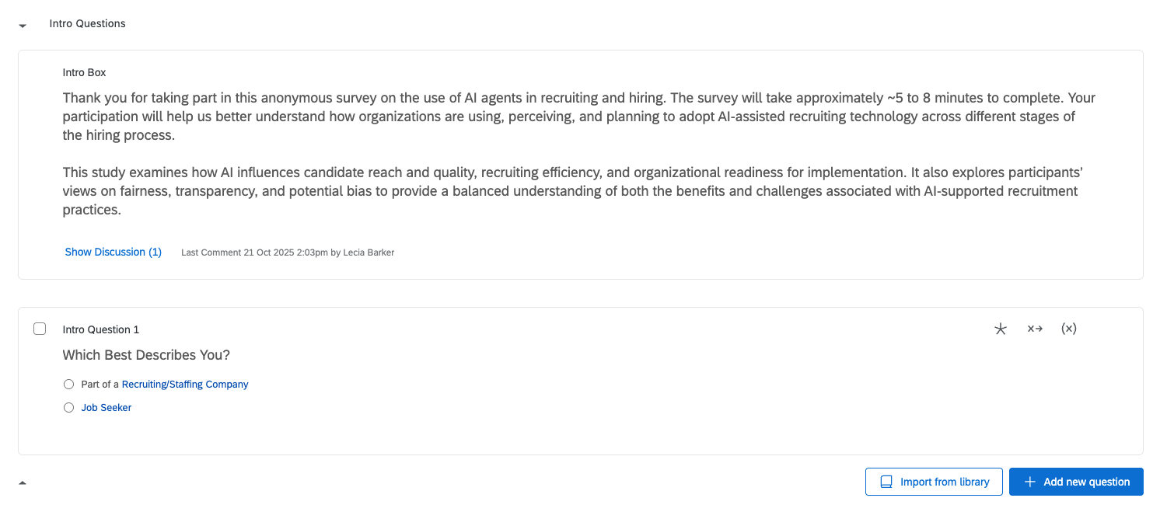
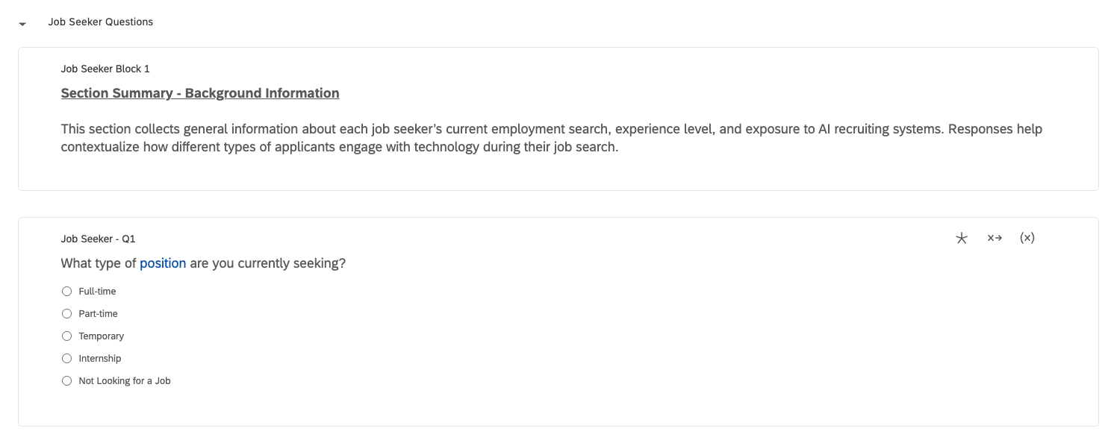
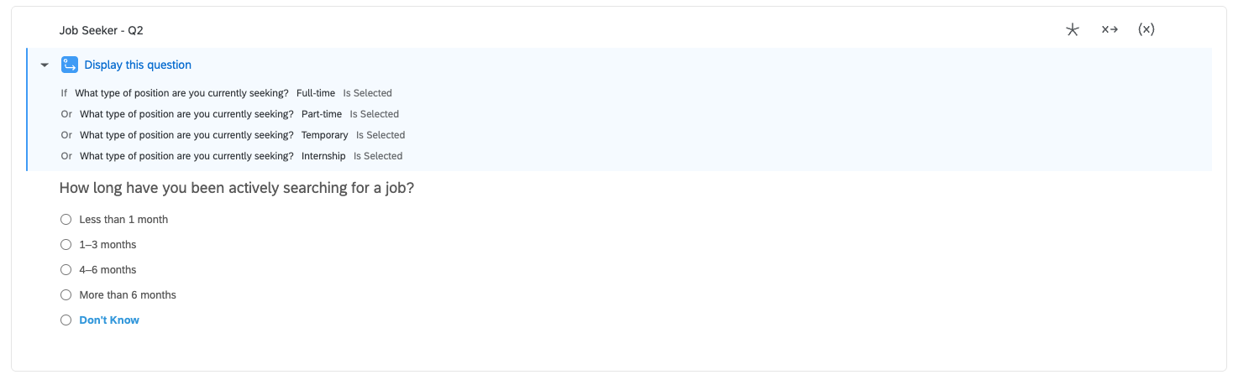
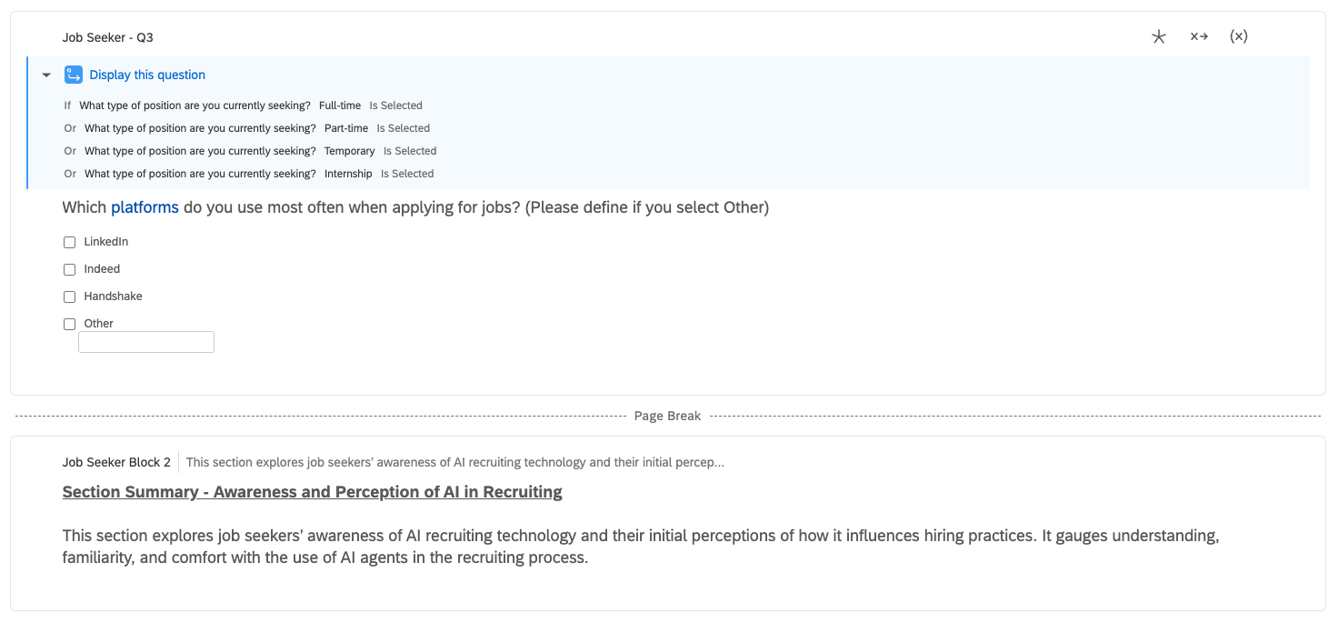
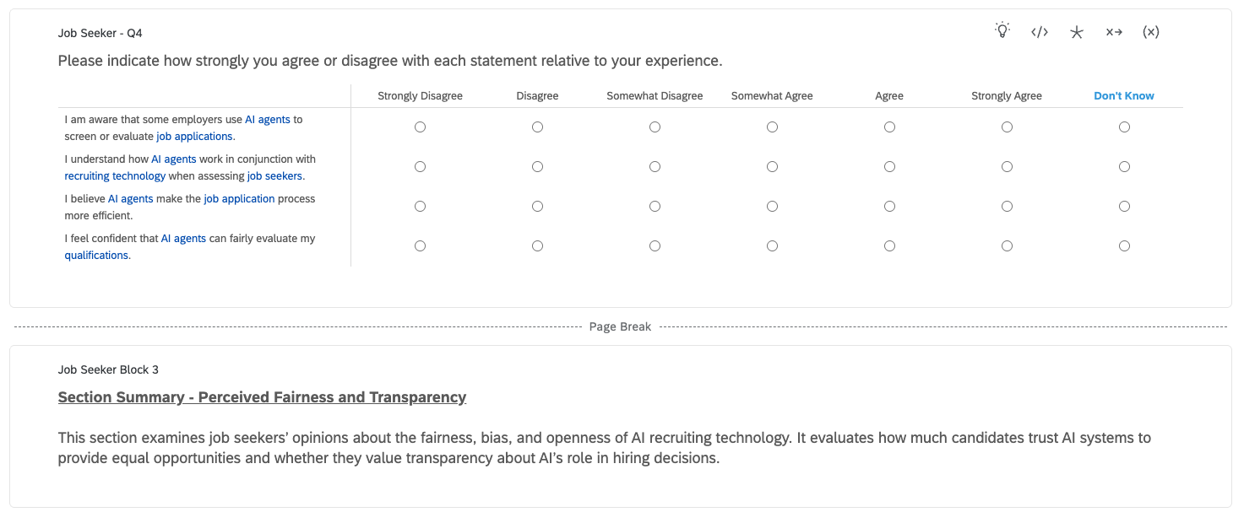
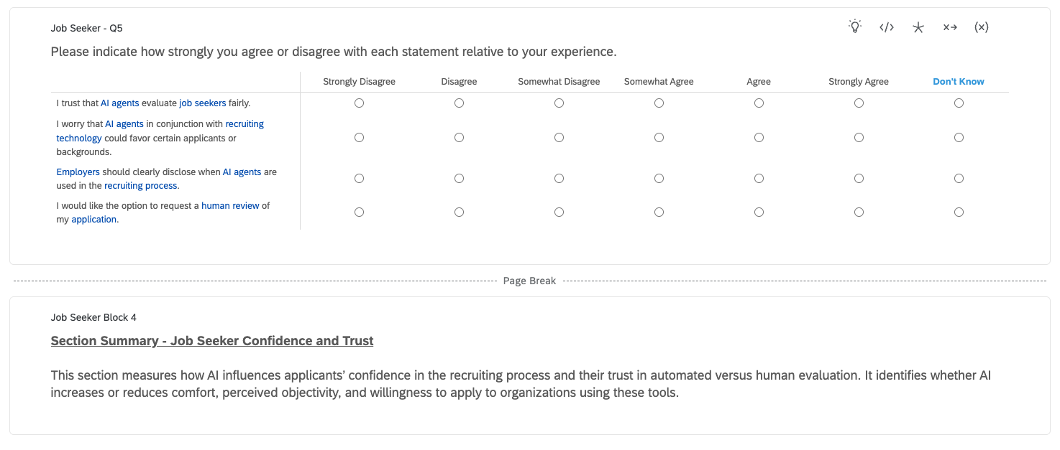
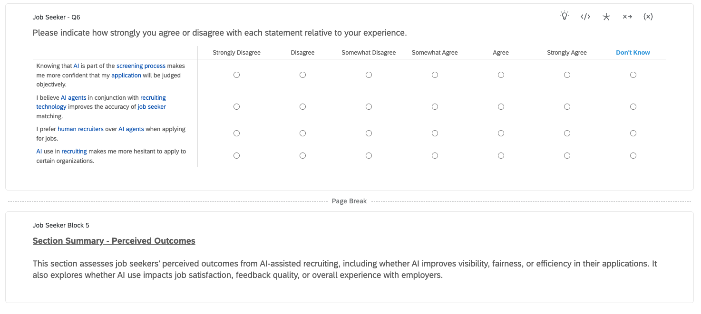
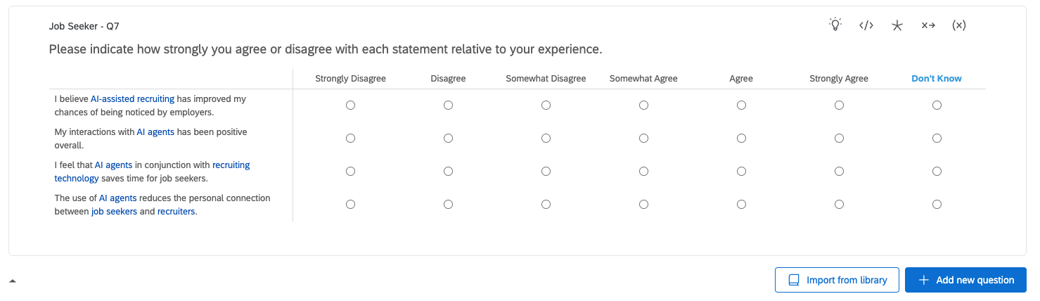
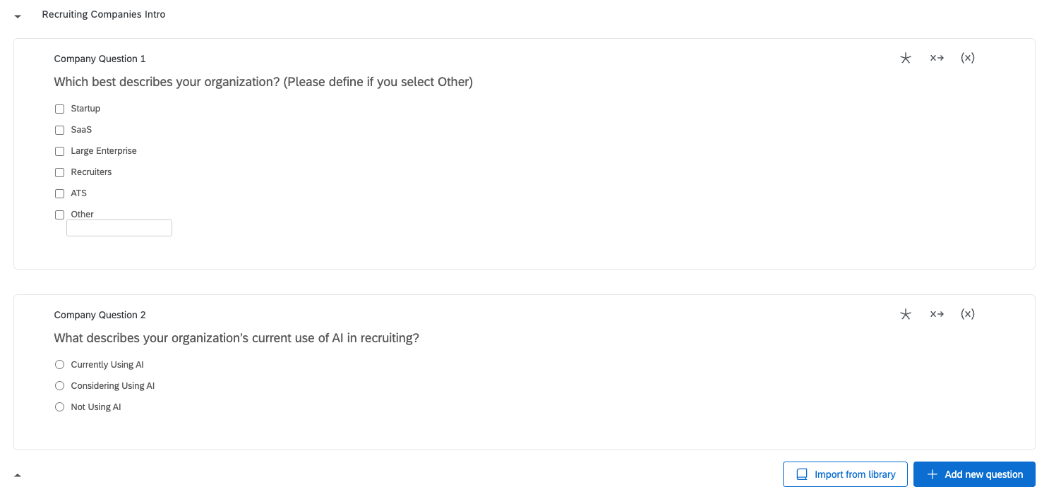
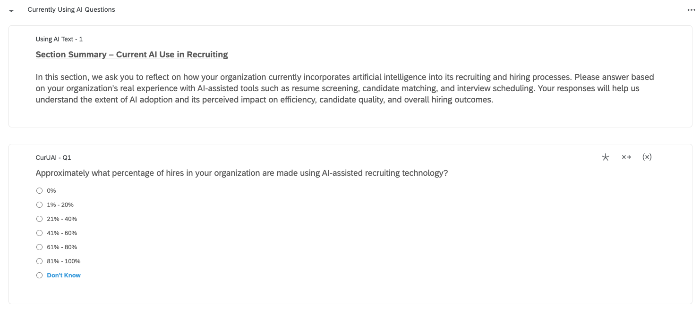
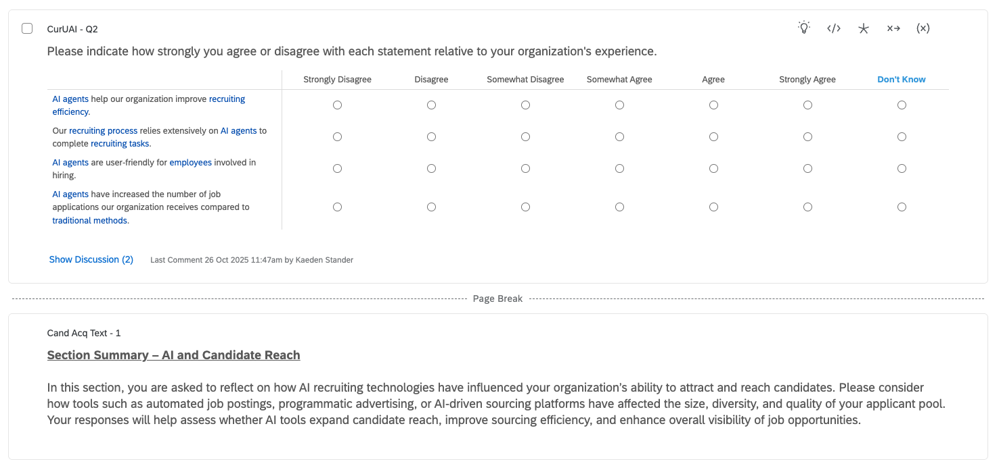
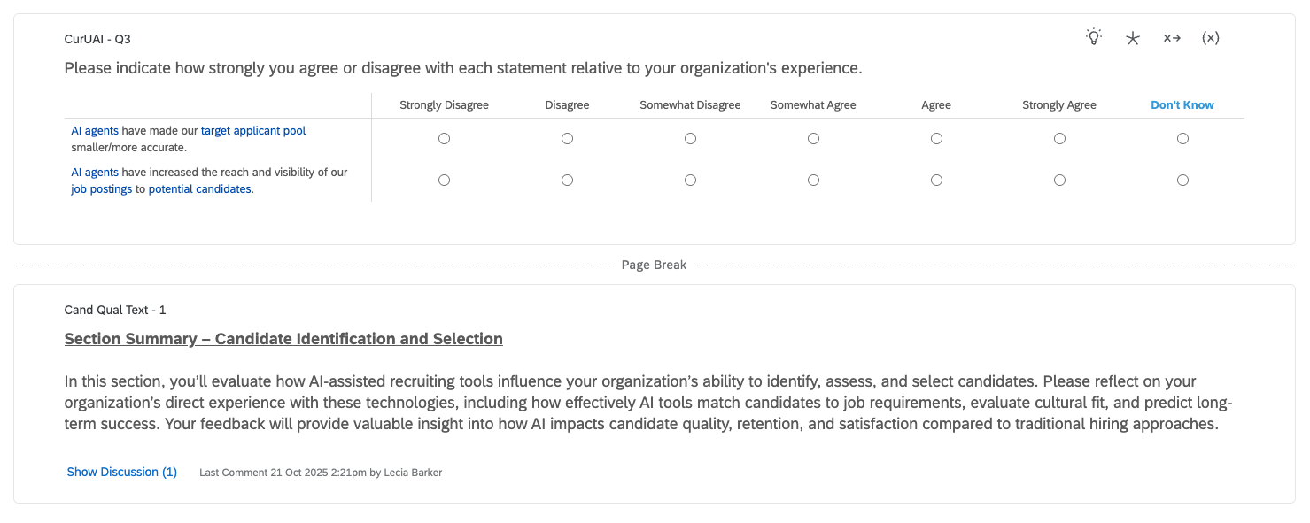
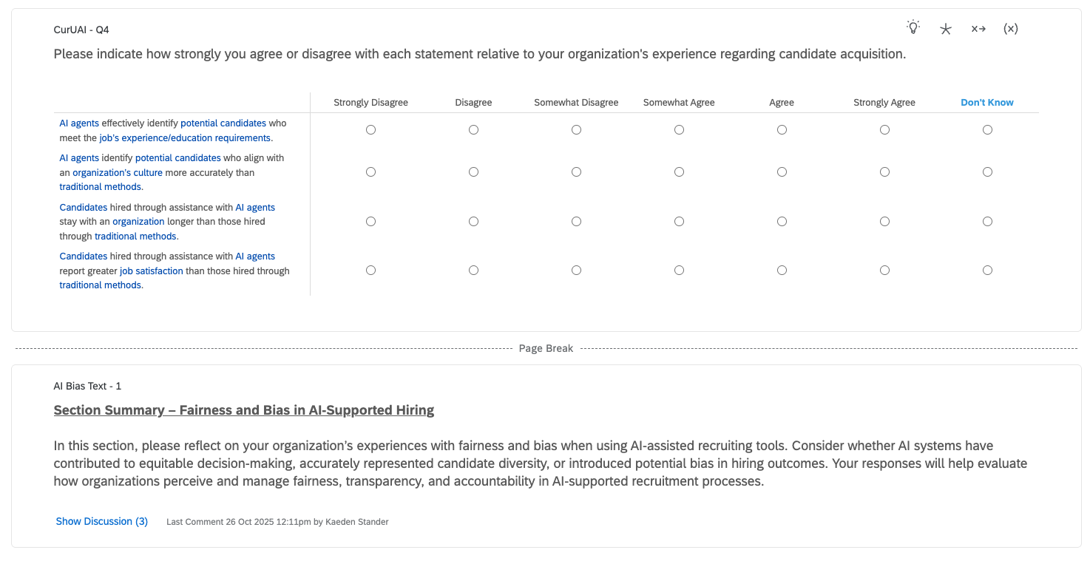
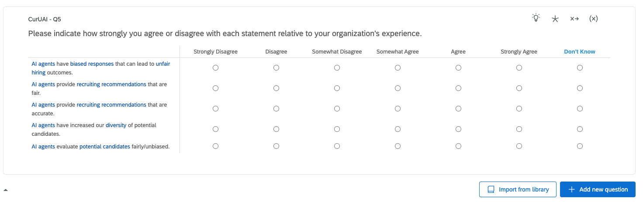
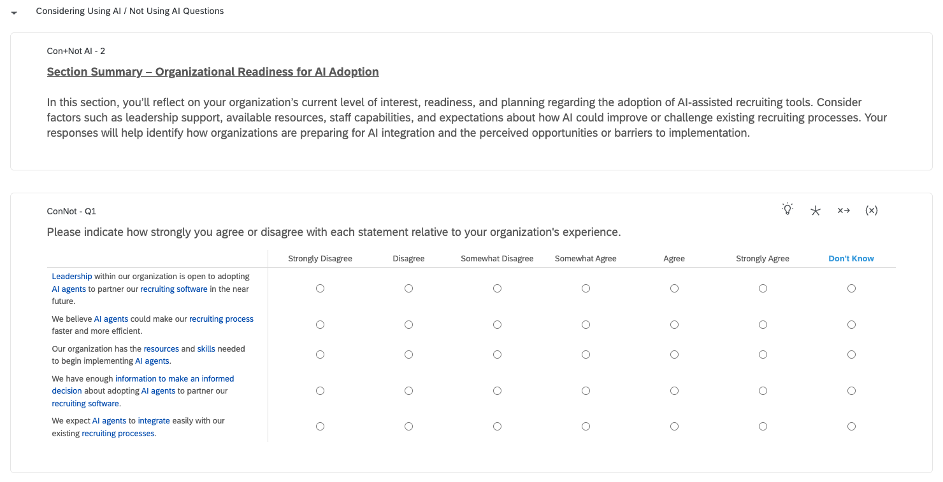
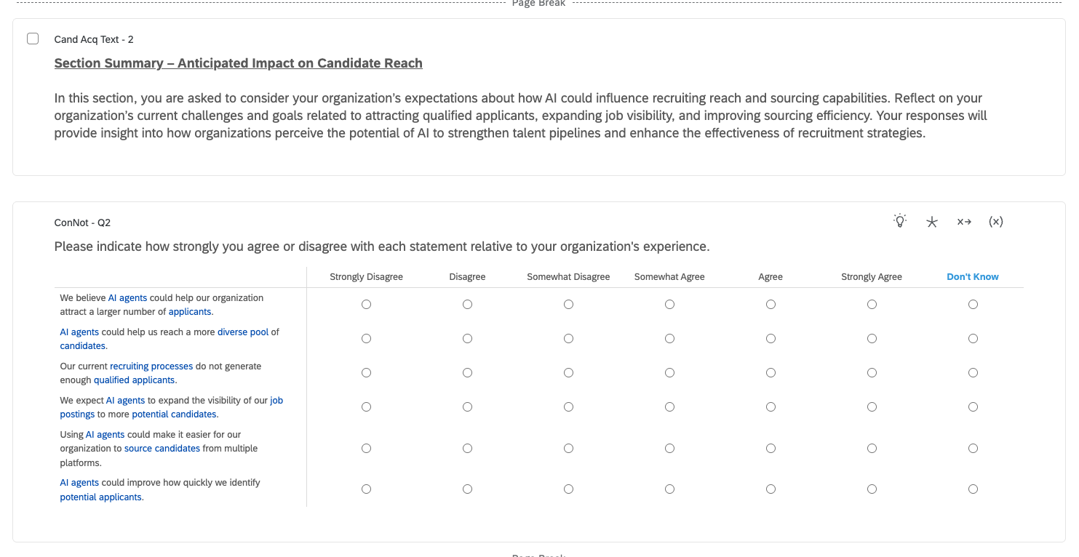
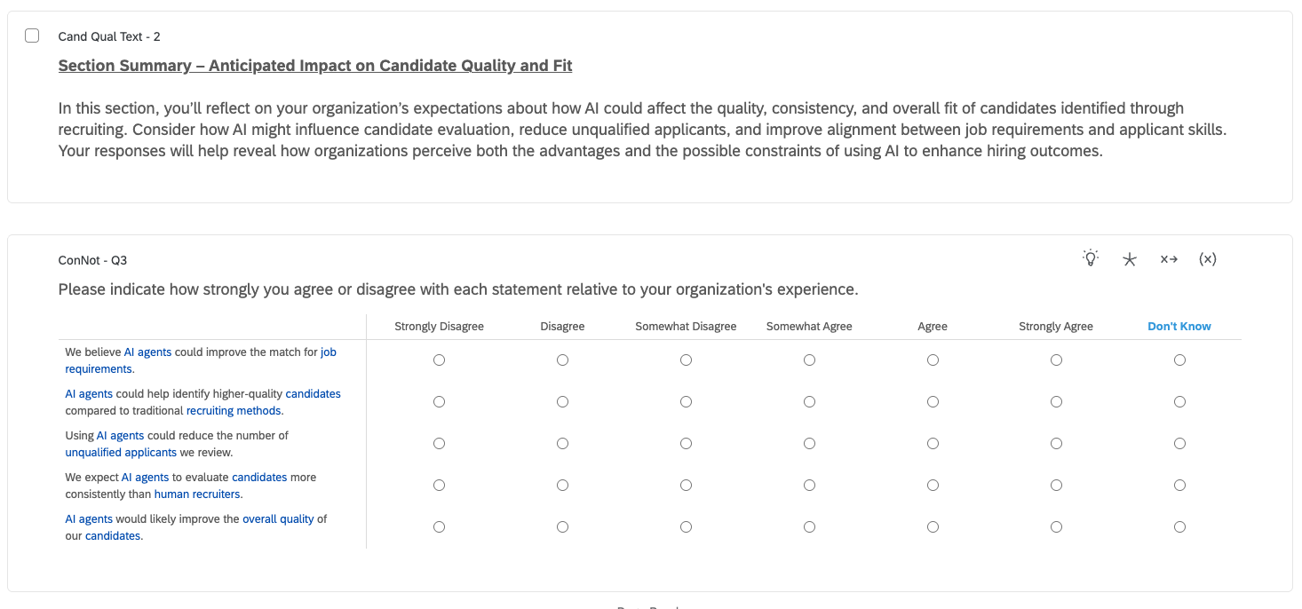
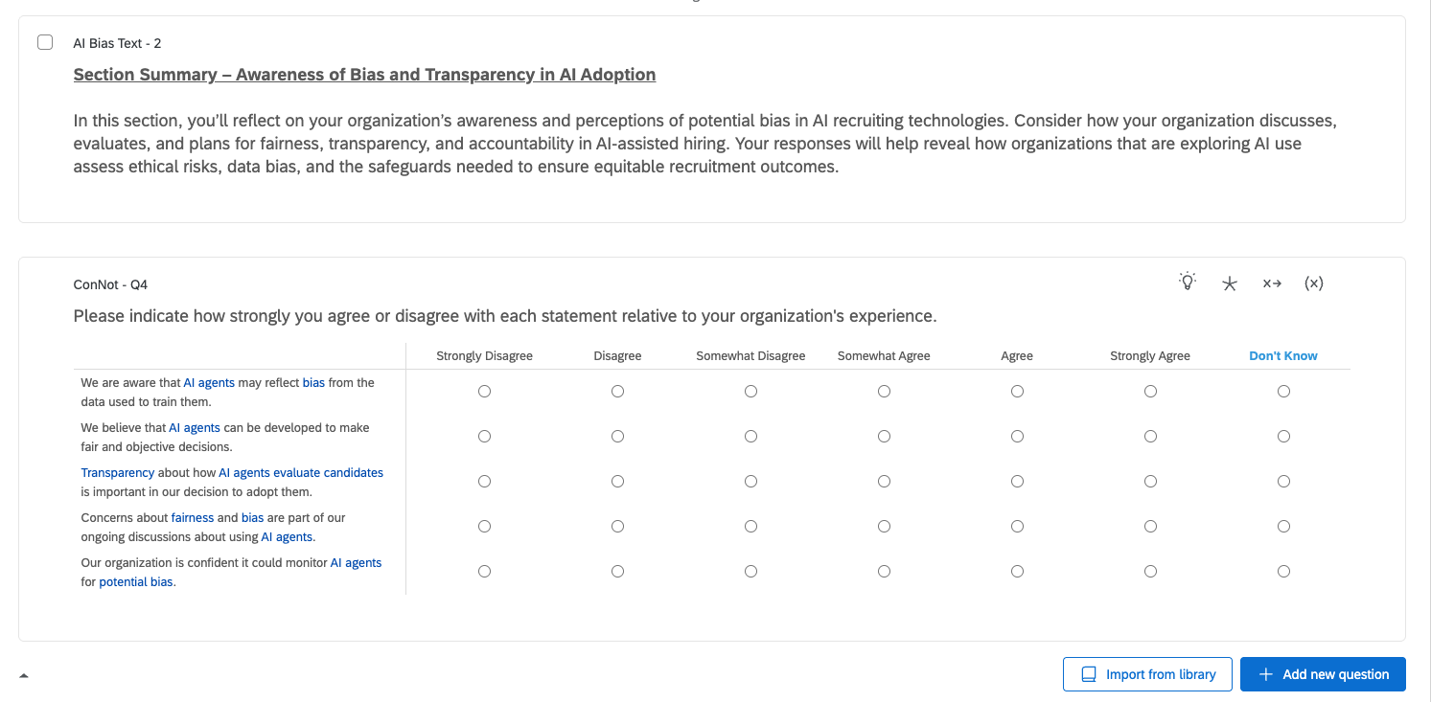
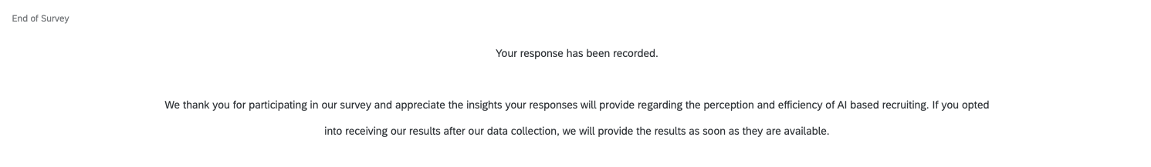

Appendix D - Data Dictionary
Appendix D - Data Dictionary
Recruiting/AI - Data Dictionary

Appendix E - Pilot Testing Results
Appendix E - Pilot Testing Results
Kaeden & Mazzy:
We distributed the survey in a preliminary sense to Jack, CEO of Staffing Future. Jack gave us a few suggestions on how to improve some of the definitions we have by improving the definitions based on his experience in the industry, and making sure we have no duplicate definitions across the beginning of each section. Both Mazzy and I will implement these suggestions next week when we revise our survey in Qualtrics. Apart from this, Jack said the survey had a good logical flow and made sense and even gave us some insights on how to best capture our sample with ease and convenience to both parties.

Daniel:
I pulled out a survey to my supervisor in the Office of Financial Aid here on campus. My supervisor is responsible for hiring all peer advisors like myself. They currently do not use AI in their hiring process. Mostly positive feedback was given around the definitions, however they noticed a few instances where the questions sounded similar. Specifically question 3 and 4 on the second section of the survey if “recruiting” and “considering AI” is selected.

Seoyoung & Jessaca:
Seoyoung: I distributed the survey to a friend who is currently working at a company. He mentioned that having definitions at the beginning of each section was helpful because it allowed them to better understand the meaning of key terms and respond to the questions more accurately. However, he suggested making the explanations above the definitions a bit more concise. Other than that, most of the feedback was positive. He also mentioned that the survey didn’t take too long to complete, so it didn’t feel burdensome to participate.

Jessaca: I gave the survey to my dad, who works in logistics and hiring for the Walmart Distribution Center, he said that it was fine for what we wanted to produce, however some terminology could be better worded for the purposes of clarification. He suggested that we define terms early in the survey and stay consistent to avoid confusion. He mainly gave positive feedback for the overall tone and delivery.

Appendix F - Launch and Monitoring Plan
Appendix F - Launch and Monitoring Plan
Launch Info
- Results Dashboard
- 8:00AM November 11th, 2025
- Mazzy, Daniel, Kaeden will address survey errors within the first 20-30 responses
- Email either Daniel with issues, will then forward issue to Mazzy to collaborate on solution
- Separate spreadsheet that all team members have access to where all survey errors are documented
- Skipped questions, abandoned surveys, responding with same answer on every question, one person taking the survey more than once

Bounces
- If emailing the survey link, what you will do about bounces (e.g., just ignore them? try to identify correct emails?)
  - For some key respondents in the overall sample (e.g., CEOs or HR), verify their email addresses and resend the survey
- Who will be assigned to do this work, when?
  - Seoyoung, Jessaca / will be responsible, conducting the work as soon as bounces are identified after the survey is sent.
- How will you document bounce repairs?
  - Record bounced email addresses, corrected addresses, resend dates, and status in Excel or Google Sheets
  - Track whether the resend was successful, including response status

Responsiveness and Inquiries
- What email address will you provide to respondents for reporting errors or asking questions? How will you track who has written and whether a member of your team has responded?
  - We will provide an additional email account specifically for questions and reporting. A couple of members from our group will be monitoring it for activity. We will check the in and outbox for responses before replying and potentially text when we offer responses.
- If collecting email addresses or other identifying information for various purposes (sending reports, administering incentives, etc.)
  - How will you maintain confidentiality?
    - We will BCC the recipients of the results of our survey to maintain confidentiality from our generated email account.
  - If providing incentives, how will these be administered? Who will do this? How will you track who has received the incentive and who hasn't?
    - We will send the results all at once to those who have requested it through BCCing them.
- If sending out survey results or other reports, when will this be done? Who will provide the report? or: Will you post as a website? Will you display live results
  - We will provide the report via email.

