Contents
Contents
Final Paper
- Introduction
- Methodology
- Ethical Analysis
- Policy Recommendation
- Reflection and Divergence
  - Jeff
  - Kaeden
  - Daniel
  - Group Reflection
- Future Direction

Appendix
- Appendix A: Codebook Analysis
- Appendix B: Visualizations
- Appendix C: Survey Data
- Appendix D: Annotated Bibliography
- Appendix E: Final Presentation

Final Paper
Introduction
The 2024 United States Presidential election was unique due to the return of President Donald Trump, the withdrawal of former President Joe Biden, and Vice President Kamala Harris taking over the race against Donald Trump. This election had many unique components; however, the one feature we had never experienced before was the use and influence of AI. With AI systems publicly available, their influence at every point throughout this election process was bound to occur. The issues resulting from this AI implementation affect more than just one area of society; however, for this analysis, the focus will primarily be on the 2024 United States Presidential election.
Ethically, politically, and socially, we saw the spread of misinformation and disinformation, as well as a shift in public attitudes towards certain political parties. The spread was not limited to public discourse or to news media channels pushing an agenda, but was mainly due to AI. Ethically, the question was posed of whether AI should be used for political messaging, given its strong role in propagating disinformation. Keeping in consideration the right of free speech, what policies can be introduced to mitigate AI deception? The spread of AI disinformation has significant social and political effects, adding another layer of distrust in political messaging. The potential harm of AI in politics cannot be overstated. Deepfake software gives the public the ability to create hyperrealistic and defamatory images of political candidates at the click of a button.
There are currently a few federal policies regarding AI use in elections. Most of which were passed during the previous Biden Administration. In short, the state of current legislation is as follows: preventing deceptive or fraudulent AI-generated political content, requiring transparency and disclosure for AI use in political advertisements, and establishing standards, oversight, and support for election administrators (Kuckuk & Hooshidary, 2024). Keep in mind that this legislation was passed in the past few years. With the rapid advancements in AI and AI tools, will this legislation still apply? For example, when will, if not already, AI advance to be undetectable by the general public? Does the public feel protected? These are questions that must be answered if, as a society, we decide AI is here to stay.
The general public, AI platforms/companies, and all political parties are both victims and perpetrators of the issue we face as a society. From the perspective of the general public. As aforementioned, the more AI-generated content is produced for mis/disinformation, the blurrier the lines between what is true and what is not. We can see that such lines are blurred for each of our stakeholders. The idea of not knowing what is true and what is not did not exist in this context, even in the 2020 election. All stakeholders contributing to our issue are simultaneously the victims.

Methodology
To gauge public opinion, review current legislation, and examine the perspectives of the tech companies that manufacture the AI platforms in question, we engaged with various social media platforms, reviewed bipartisan legislation, and conducted a survey on how artificial intelligence (AI) may have influenced the 2024 presidential election. These sources together provided a well-rounded understanding of how the public, policymakers, and tech leaders view the issue.
An initial, casual approach consisted of viewing Reddit posts from subreddits about the 2024 election, as well as YouTube and Instagram posts. We found that it was a consistent way to engage with public opinion without interviewing or conducting surveys on the topic. Taking a deeper dive into policy and political discourse, we decided to look at policy and recent developments from the United States Congress, as well as interviews and speeches from our current and past administrations. Data from these sources provided a transparent view from the federal government's stakeholder perspective. The information pulled from the federal government provided a way to view all current policies and determine where the administration stands on them, to predict future policies and legislation. The last stakeholder perspective we considered was leaders in big tech. We examined articles and reports from numerous sources on big tech's actions and its role in this issue, including statements from executives themselves. From these three stakeholders, the main theme patterns we detected were anger, happiness, accountability, risk, solution, and collaboration (Appendix A). Although these themes generally capture the overall perspective of all three stakeholders, our initial research may have limitations. When pulling comments and posts from social media platforms, it is, of course, nearly impossible to verify the credibility of the person sharing their opinion. For this reason, we mainly wanted to measure opinion on the topic, rather than the amount of knowledge about it.
The goal of our survey was to gauge public opinion on AI use in politics among our own networks and peers. We used a mix of matrix, open-ended, and free-response questions. The question structure allowed us to ask questions that would either confirm or deny the themes we developed, as well as to identify any additional information or themes we may have missed in our manual coding process, without relying on AI. To distribute this survey, we mainly reached out to our own networks: close family and friends, and classmates. The main questions in our survey focused on how AI influenced the 2024 United States Presidential Election. Some of these questions included opinions on regulation, anxiety, stress, confidence, and trust around AI’s role in this election. We found that an overwhelming majority believed there should be stronger regulation of AI, not only in the context of the 2024 Presidential Election but in politics as a whole.
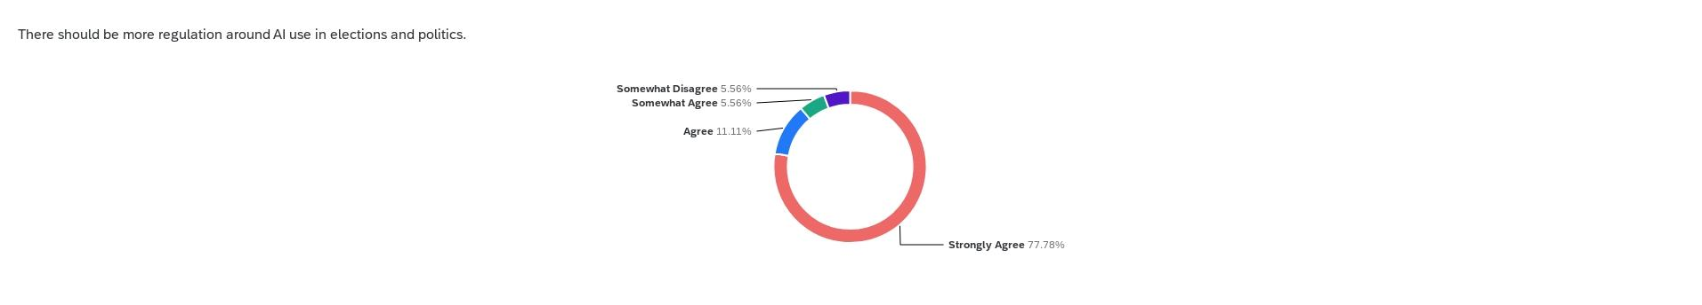
Figure 1
We found that nearly 90% of respondents believed AI needed significantly more regulation in politics and elections, past and future. Responses to a controversial single question in our survey represent, on a larger scale, the results of the entire study. Our survey confirmed not only what we believed, but also what we observed within our manual coding.

Ethical Analysis
By analyzing AI and the 2024 United States Presidential election through various ethical frameworks, the three that align most closely with the issue are utilitarianism, deontology, and virtue ethics. Considering the three aforementioned stakeholders from a utilitarian perspective, there are many outcomes and trade-offs. The first outcome is more regulation of AI and greater awareness of misinformation in politics as a whole. While the focus of this research is primarily on AI use and the 2024 United States Presidential Election, such a shift can serve as a gateway for future AI mis/disinformation. We believe, as aforementioned, that all stakeholders can be victims and perpetrators of this issue; in this case, we also believe big tech and political parties are most likely to be harmed, while the general public is most likely to benefit, encapsulating the idea of mis/disinformation being cut back due to oversight and regulation.
If we evaluate our issue through the deontological lens, we must examine all duties, rights, and principles, as well as all rules, regulations, and policies relevant to the matter. Also, identifying the conflicts that may arise from this lens helps us identify areas where a different ethical lens may be necessary, as well as any shortcomings of this lens. From a deontological perspective, the idea of increased regulation and policy around AI use in this context means that no one will be completely satisfied; however, it allows for the most equitable treatment for all stakeholders. Equitable in how the general public is informed about misinformation, big tech will take a more ethical stance on AI use, considering the algorithms involved, and political parties will have to rely less on AI to inform their supporters. Most big tech leaders may see this as a way to censor their platforms, and political parties may view any regulation as an infringement on the First Amendment.
Virtue ethics, the final framework we will be comparing to this issue, requires us to identify all habits, character traits, and/or values that may be reinforced or neglected. Within this specific framework, the main habit currently not practiced by politicians who use AI is the use of a disclaimer when posting AI-generated content. Transparency about AI use is a basis for all uses of AI in politics. Some could argue that, if harsh policies around AI may infringe on specific amendments, by mandating transparency on usage, big tech does not have to change the way it formulates algorithms, the general public is warned accordingly, and politicians leave the interpretation of their AI content to the user.
Virtue ethics is the clear winner. Rather than changing how AI is used or made, crafting policy around transparency is the best solution to our issue. Crafting policy around openness will ensure that no rights of any of the mentioned and potential stakeholders are infringed upon. By examining this issue through various ethical frameworks, we identified flaws and gaps. Within the other two frameworks that were not considered most useful, the utilitarian framework lacked equity for all, and the deontological framework involved too much regulation. With the preferred ethical framework in mind, we can use our reasoning to take a deep dive into potential policies regarding AI use.

Policy Recommendation
The presence of AI within our society is an undeniable factor we must consider when developing regulations to protect the sanctity of fair elections and freedom of speech. Such a factor is not stagnant, however, as AI is constantly evolving and advancing to create more realistic synthetic media. As such, the regulations in place must be developed in accordance with AI systems to adequately protect the validity of information received by the American people while simultaneously preserving the right to freedom of speech. Navigating these necessities when developing policy on AI use and distribution is a difficult task, one that has been discussed extensively by the public, government officials, and social media executives (Appendix D). By analyzing stakeholder discourse on AI’s influence in the 2024 presidential election, we have developed a proposal for addressing AI interference in future elections.
The bottom line is that clear communication must be prioritized from the distributor to the receiver of all synthetically generated media. As mentioned above, such a level of transparency provides the greatest affordances to the examined stakeholders while limiting disaffordances. The reason communication about AI-generated media is so important is that we have found the public primarily values AI transparency while simultaneously fearing AI deception. From a study conducted across three different universities to gauge the current level of public concern about AI disinformation, an important conclusion can be made. More specifically, after viewing examples of AI-generated deceptive election content, public support for an immediate moratorium on AI rose nine percentage points, from 29% to 38%, indicating substantial concern about manipulation (Jungherr et al., 2024).

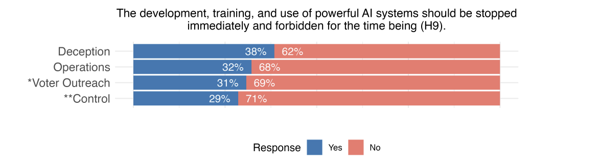
Figure 2.

The study was conducted in comparison with a control group that was uninformed of how AI can and has been used to mislead the public on specific political issues. Among this group, 29% of respondents supported an immediate halt to the development and research of AI tools. Compared with the group informed about how AI can mislead the public at large, support for quickly stopping AI development rose to 38%. A stark 9% increase in support for stopping AI development suggests that when individuals are simply aware that these tools can be used with effective manipulative intent, concern grows. The conclusion is supported by our personal survey data as well. When respondents were asked whether they were concerned that AI contributed to the spread of disinformation during the period preceding the 2024 U.S. presidential election, ~97%agreed, with levels of concern ranging from strong to somewhat.
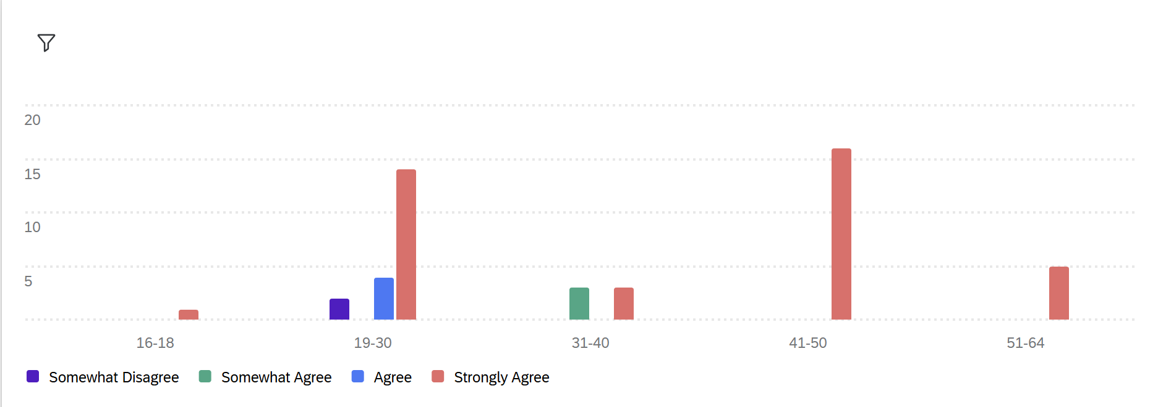
Figure 3.
It is also worth noting that this concern stems from the public’s level of confidence in current social media AI protection policies. When asked if respondents were confident that online platforms effectively monitored and labeled synthetic media to prevent misinformation before the 2024 presidential election, an overwhelming majority disagreed.
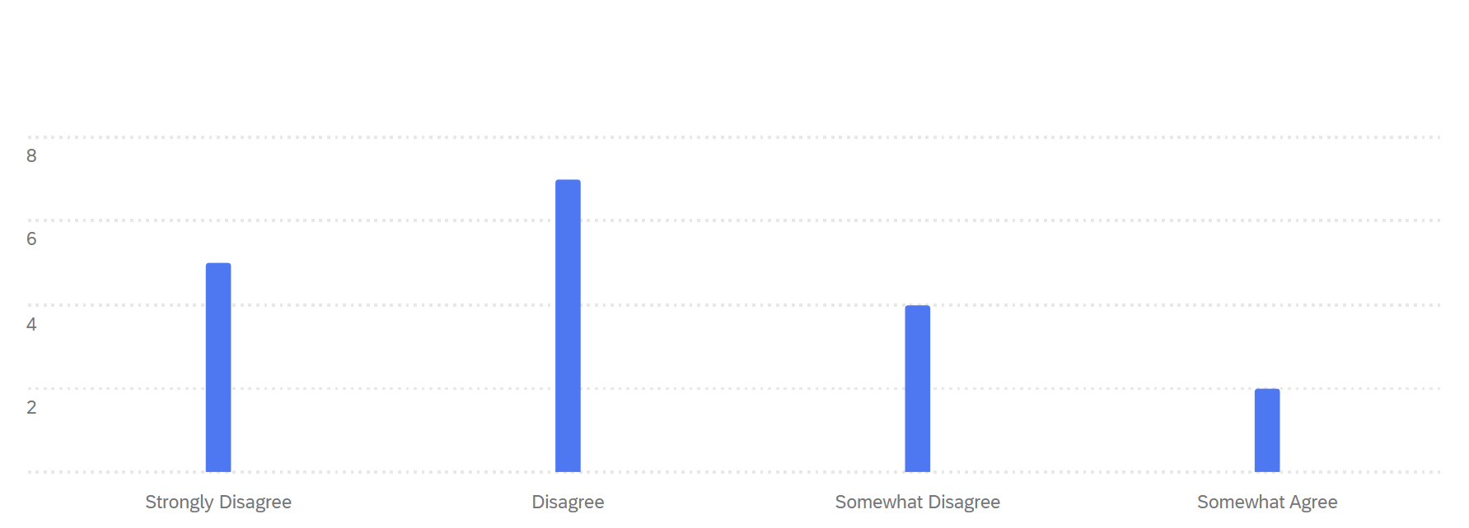
Figure 4.
Now, to extract this information into actionable policies, we can use our conclusions to guide our next steps. Although Figure 1 suggests heightened public interest in halting AI development outright, this approach is extreme and would impose unfair disadvantages on all stakeholders, as any benefits from AI would be rendered obsolete. Rather than taking the question literally, we can understand that the data indicates the public is significantly concerned about being manipulated as AI development continues, and lacks faith in current regulations. The results derived from both primary and secondary studies provide reasonable guidance for developing a policy that limits extreme disaffordances for specific stakeholders while maintaining individual rights and protections. As mentioned before, the ideal policy should enforce a level of public communication that limits the deceptive potential of synthetically generated media, especially as it relates to political messaging. What does this enforcement of communication look like in practice? It depends on the type of AI media and the distributor.
For video and image-based synthetic media, enforcement would require a persistent on-screen disclosure indicating when the video or image has been artificially generated or modified. The disclosure should follow a standardized set of rules for the size, placement, and clarity so that they cannot be hidden from the viewer. To reinforce this, the platform on which the AI media was generated should always encode an unremovable warning into the media’s metadata. An indicator will tell the social media platform on which it is distributed to include a secondary AI indicator on the post itself. Therefore, any public concern about watermark inefficiencies can be addressed by embedding concrete identifiers in the metadata itself.
For any audio-based media that has been altered or fabricated using AI, the communication enforcement would appear as an audible warning. Similar to the fast list of disclaimers at the end of pharmaceutical advertisements, AI-altered audio media would use the same approach. The altered sound clip must play in its entirety and include a verbal AI indicator at the end; otherwise, the post would be removed from the platform. Such a level of accountability ensures that the listener is aware of the artificial nature of the sound clip while simultaneously protecting the creator's freedom of speech. It is worth noting that for both visual and audio synthetic media, if the content is deemed to be harassment or defamatory of a political candidate, it will be removed by the platform’s content moderators.
To further protect the sanctity of information validity in politics, campaigns that leverage AI in their messaging should be required to maintain a log of every use of AI. Each entry would include how AI was used, which platforms it was distributed to, and the date it was created. The log would be available to the public to ensure maximum clarity about the amount of artificial content leveraged by each campaign. By holding political campaigns to a higher standard of AI transparency, we can ensure synthetic media does not quietly embed itself in primary political strategy.

Reflection and Divergence
Our suggested policy changes provide the most realistic and actionable protections for the validity of online information while also protecting people's rights. These conclusions were made after thorough research and group deliberation on our topic. For most of the project, we were at a similar level of agreement on the importance of AI transparency and the implementation of policies to enforce it. To fully understand our individual perspectives on the policy development, we will each describe our thoughts below.

Jeff:
The rapid development and implementation of AI in our information systems are extremely concerning to me. My concern is particularly heightened by how it impacts our country’s long-standing democratic systems. Although my concern generally feels like a bad thing, I thought it was leveraged as a positive motivator to research and inform our policy decision for this project properly. Discussing this concern with Kaeden and Daniel showed me that I was not alone. Expanding on my thoughts by coding sentiment from statements by current tech leaders helped me understand concerns about AI across different contexts. Understanding how each stakeholder group felt uniquely concerned about AI management in elections added valuable depth to our policy discussions. I believe our project has resulted in a well-rounded set of policies that limit AI’s deceptive capacity in elections.

Kaeden:
What concerns me most is not just what AI can do today, but what it will mean for the next election cycle, when its capabilities are even harder to detect or control. Such uncertainty makes me question how our democracy and overarching democratic process will preserve honesty, trust, and accountability as technology continues to move faster than regulation. The method of analyzing public discourse and developing policy proposals, especially when it comes to our elections, has made me realize that ethics in technology is not about stopping progress, but about ensuring it evolves responsibly. My concern for the future of our democracy lies in whether society can adapt quickly enough to protect democratic values before they’re quietly rewritten by systems we no longer fully understand, and that understand us.

Daniel:
Our democratic process in the United States seems to be tested every day. When our systems are tested, we can look back in history and see what went wrong and how to resolve the issue. For our specific topic, we have nothing to look back on. We are the first generation ever to face this dilemma. The idea of not having anything to reflect on for guidance is what makes the dilemma not only hard to resolve but also hard to convince the public of the severity of the issue. The coding process of this project reinforced my feelings of uncertainty, anxiety, and severity. By reviewing pioneering policies and discourse on this topic, we were able to see not only public opinion on the matter, but also a glimpse of what our generation and future generations will have to work towards to advance the work being done now.

Group Reflection:
As a group, understanding how AI has seamlessly integrated into our elections and democracy has left us with a deep sense of both urgency and responsibility. We entered our research curious about how AI might affect elections, but we have taken away an understanding of how quickly it’s reshaping the foundations of democracy itself. Across our discussions, one emotion connected us more than any other - fear. Not fear of technology itself, but fear of how unregulated, opaque systems can distort truth faster than policy or public awareness can respond. Through our coding and analysis, we found that people share this unease online, and our primary survey revealed that the discussion extended the overarching public discourse. The duality became central to our thinking: AI isn’t inherently destructive, but its unchecked influence in political spaces can quietly shift what people believe to be real.
Working together helped us see that ethics, transparency, and accountability aren’t abstract ideals; they’re survival mechanisms for democracy in a digital age. While our individual reflections focus on different aspects of this issue, we all agree that society must move beyond merely reacting to AI’s problems and start building regulations to prevent repeat issues. Our project ultimately reminded us that the future of ethical technology isn’t about opposing innovation, but guiding it, ensuring that progress serves people, not the other way around.

Future Direction
For our specific topic, there are advancements nearly every day, creating new concerns. This alone makes it hard to predict the future of this issue. Given how fast this industry is evolving, AI and certain AI products risk becoming too realistic. Large language learning models (LLMs), deepfakes, speech recognition, and any other byproduct of AI are becoming too real for people to identify, raising the question: If we are already struggling to tackle these AI dilemmas, how hard will it be in the next presidential election? What will campaigning look like? What will debates look like? These are all questions that we simply can not answer at the moment. Currently and in the near future, we are seeing AI used for gains outside of elections and campaigning. Our current administration's use of AI and deepfakes is being used for political gain in attempts to slander any opponents. Policy not only on elections but also on AI usage, with an emphasis on defamation, discrimination, and even incitement of violence, is the next step.

Works Cited

Works Cited
Kuckuk, A., & Hooshidary, S. (2024, September 12). Brief AI in Elections: A Look at the Federal and State Legislative Landscape. National Conference of State Legislatures. Retrieved November 20, 2025, from https://www.ncsl.org/elections-and-campaigns/ai-in-elections-a-look-at-the-federal-and-state-legislative-landscape
Jungherr, Andreas, Adrian Rauchfleisch, and Alexander Wuttke. “Deceptive Uses of Artificial Intelligence in Elections Strengthen Support for AI Ban.” University of Bamberg, National Taiwan University, and LMU Munich, 26 Aug. 2024. https://static.poder360.com.br/2024/08/uso-ia-eleicoes-banimento-pesquisa-26ago2024

Appendix

Appendix B - Visualizations
Figure 1 -

Figure 2 - Support for forbidding AI development from respondents shown different types of synthetic media

Figure 3- “Should there be stronger regulation around AI usage in elections and politics?”

Figure 4 - “I felt confident that online platforms effectively monitored and labeled synthetic media to prevent misinformation.”

